Mathematics Methods Investigations

Year 12

Topic 2: Integrals

Authors: Rom Cirillo
Margaret Denham
Jo Giumelli
James Heseltine

Editors: Rom Cirillo
Ann Shugg

For each topic three types of tasks are included:
Extended investigation – an investigation which could be done in the student’s own time followed by an in-class validation. Solutions are provided where practicable for the preparation activity/investigation. For the in-class validation, there are solutions and marking keys which identify the mathematical behaviours that students may exhibit.
In-class investigation – an investigation for which no prior preparation is required. Solutions and marking keys are provided.
Investigative questions – a series of short questions which test the student’s ability to apply their learning, to justify their conclusions, to investigate and to generalise, or to solve problems. Such questions could be included in a response or examination assessment. Solutions and marking key are provided.

Screen shot have been produced using the CASIO ClassPad II emulator or the ti-nspire CAS emulator.

Most graphs and diagrams have been produced using efofex software.

© The investigations and solutions in this publication are for the sole use of staff and students of the purchasing school. It is a breach of copyright to distribute them in whole or part in any form now or in the future to any other school, company or person.

Contents:
MATHEMATICS METHODS: Year 12
3.1 Further differentiation and applications
Task 1: Extended investigation: The second derivative
Task 2: In-class investigation: Taylor series
Task 3: Investigative questions

3.2 Integrals
Task 4: Extended investigation: Area between functions
Task 5: In-class investigation: Areas between graphs and the x-axis
Task 6: Investigative questions

3.3 Discrete random variables
Task7: Extended investigation: Distribution of sample means
Task 8: In-class investigation: Binomial distribution
Task 9: Investigative questions

4.1 The logarithmic function
Task10: Extended investigation: Logarithms
Task 11: In-class investigation: The logarithm function
Task 12: Investigative questions

4.2 Continuous random variables and the normal distribution
Task13: Extended investigation: The Normal distribution curve
Task 14: In-class investigation: Continuous distribution curves
Task 15: Investigative questions

4.3 Interval estimates for proportions
Task16: Extended investigation: TBA
Task 17: In-class investigation: TBA
Task 18: Investigative questions

This package only contains the investigations associated with topic 3.2: Integrals

If your school has purchased the complete set of 18 investigations, you will be informed when the rest are ready for delivery/download.

TASK 4: Areas between Functions

Extended Investigation

Unit 3

Topic 3.2: Integrals

Course-related information
The concepts included in this investigation relate to the following dot points within the WA Mathematics Methods syllabus:
3.2.10 examine the area problem and use sums of the form $\sum_{i}{f\left(x_{i}\right) δx_{i}}$ to estimate the area under the curve $y=f(x)$
3.2.11 identify the definite integral $\int_{a}^{b}{f\left(x\right)dx }$as a limit of sums of the form $\sum_{i}{f\left(x_{i}\right) δx_{i}}$
3.2.12 interpret the definite integral $\int_{a}^{b}{f\left(x\right)dx }$as area under the curve $y=f\left(x\right)$ if $f\left(x\right)>0$
    - examine the concept of the signed area function $F\left(x\right)=\int_{a}^{x}{f\left(t\right)dt}$
    - calculate the area under a curve
    - calculate the area between curves

The ability to choose and use appropriate technology to enhance and extend concept development are also incorporated within some of the items.
Background information
Students should be given this task before integration skills or concepts have been taught in class.
Task conditions
Students have a preparation section of the investigation which may be undertaken over several days, in class or at home. Students then have an in-class assessment on the content and processes of the investigation. Students should not be permitted to take the investigative material from the preparation activity into the validation task.
Students will need to have access to a CAS calculator for the in-class validation task.
They will also need to have loaded and familiarized themselves with the CAS program provided as part of the preparation activity.

Areas between functions
Extended Investigation Part 1: Preparation activity
The aim of this investigation is to look for a method of finding areas between curves by calculating the area of small ‘slices’ and adding the area of each of these slices to arrive at the total area. To save time, we will use a simple CAS program to calculate the area of the slices.
Activity one
Consider the example of finding the area between the curves for 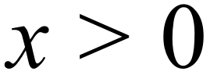 .
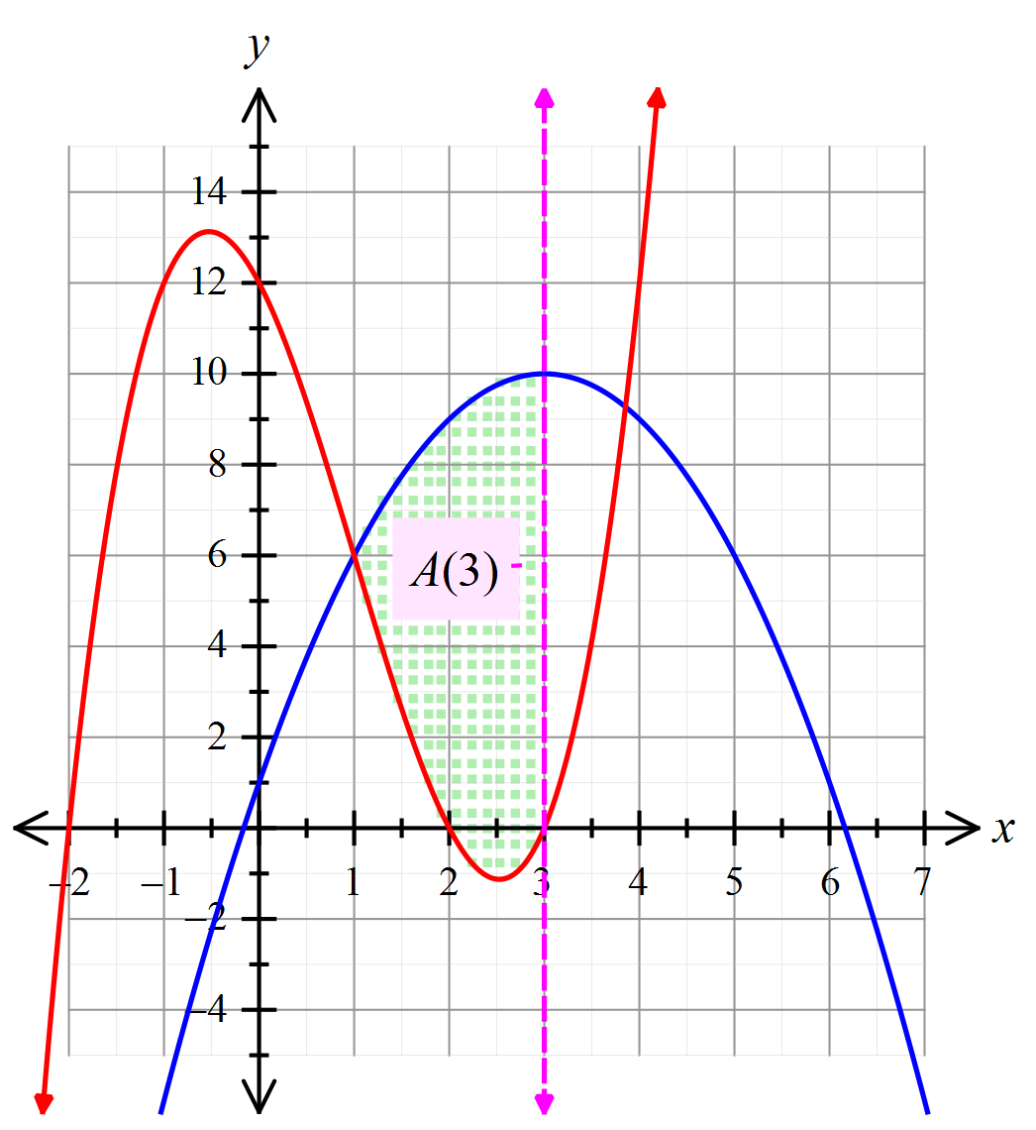
Define a function to be the area bounded by the two curves
from 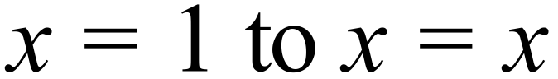 .
Then .

Now consider a ‘slice’ of this area between the two curves from 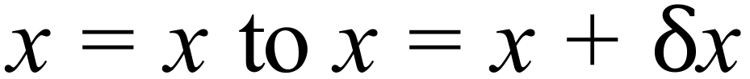 as indicated below.
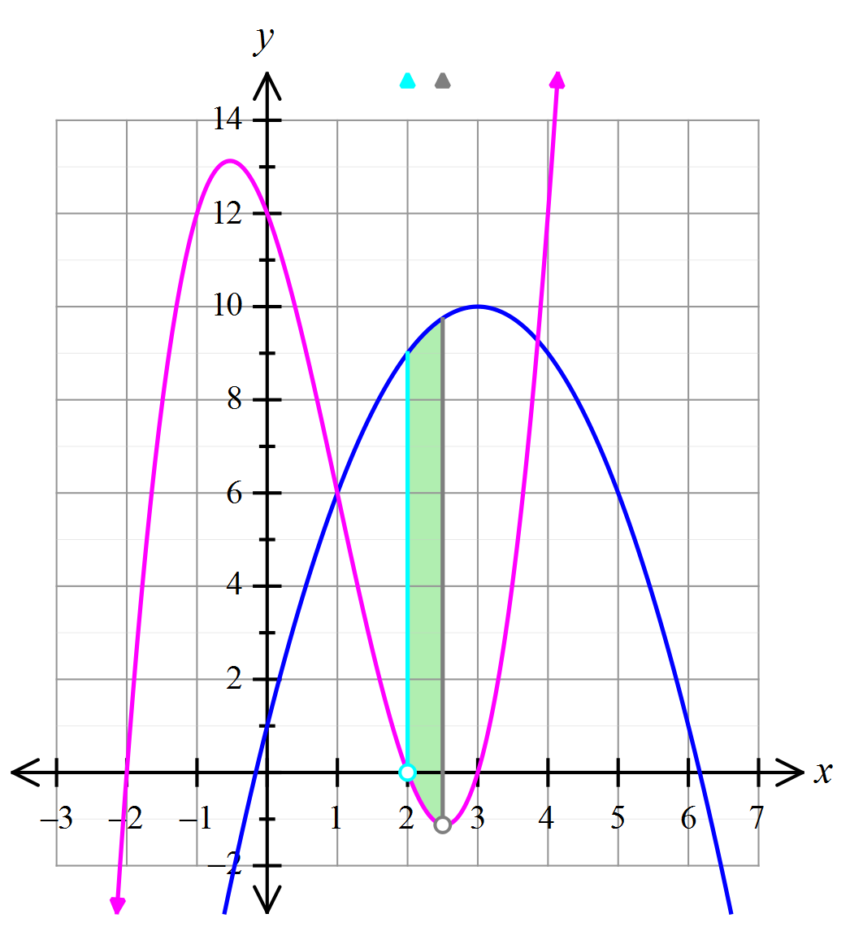
As can be seen from the graph above, the ‘slice’ approximates a trapezium with the lengths of the two parallel sides given by . For the slice drawn in the graph, 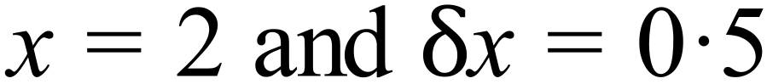, and the respective lengths of the two parallel sides are 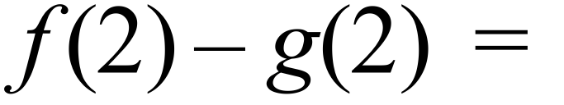 9 and 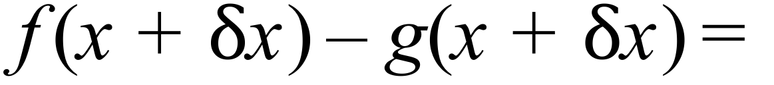 10.875
(See CAS screen shot below)
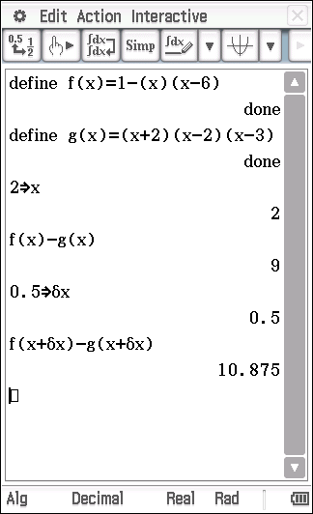
Hence the area of the slice is (approximately) 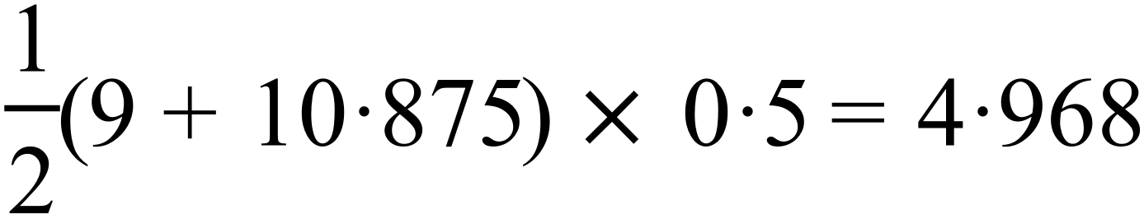 .
If we find the area of enough ‘slices’ as defined above between the two points of intersection of the curves, we will be able to determine the area between the two curves to whatever degree of accuracy is required.
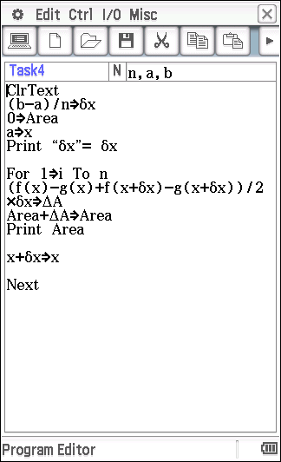
To do this in a more time efficient manner it would be helpful to use a simple CAS program similar to the one provided below.
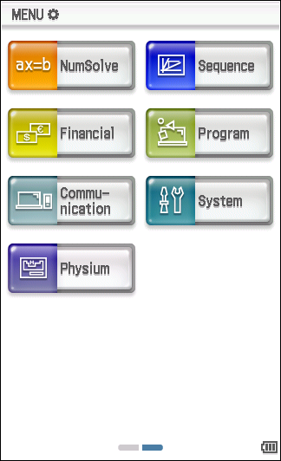
To setup this program, open the program app (second page of applications)

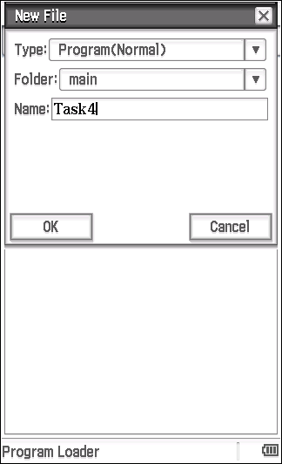
Open a new file (Edit, New File), give it a name (Task4) and select OK.

This will open the program editor. Enter the program code as indicated. Don’t forget to save the program.
The suggested program uses the parameters n, a and b. Make sure you enter these as shown, as this will allow the program to be run from main.
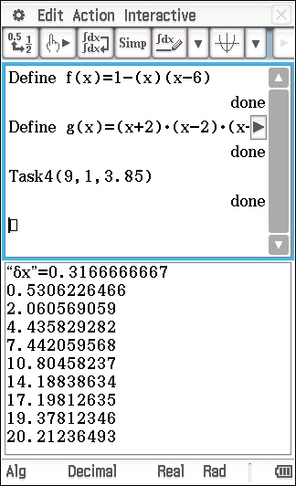
Now return to main, define the functions 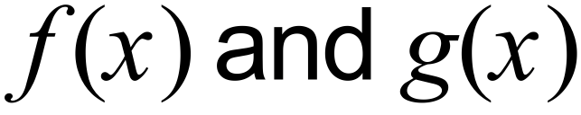 and experiment with different values of n in the program Task4(n, a, b). Note that n is the number of ‘slices’ or ‘partitions’ used to calculate the total area between a and b that is within the two curves.

The output for n=9 which results in 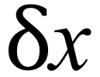 =0.3166666666… is shown.
The numbers underneath are the cumulative areas 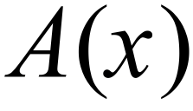 of the 9 ‘slices’. 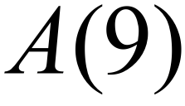 =20.212… is the total Area between the two functions.
The program may be simplified to only print the total area, but it is advised that you familiarize yourself with the program that gives each of the cumulative areas.

A modified program (Task4b) and the resulting output are shown below.
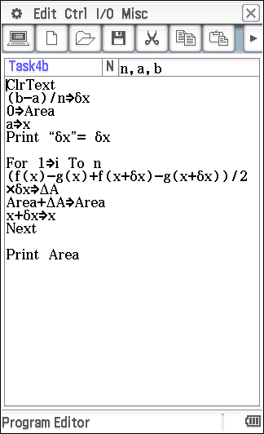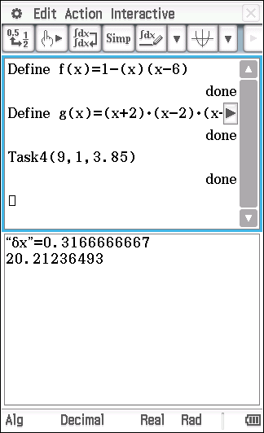
Experiment with different values of n to 100 to see what difference this might make to the area.
Activity two
Using the programs provided in Activity one, determine the area between the functions 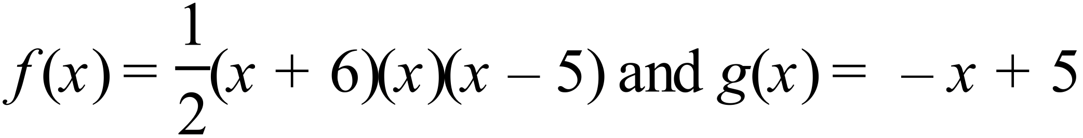 drawn below. You may use the points of intersection, rounded to 2 decimal places, as provided.
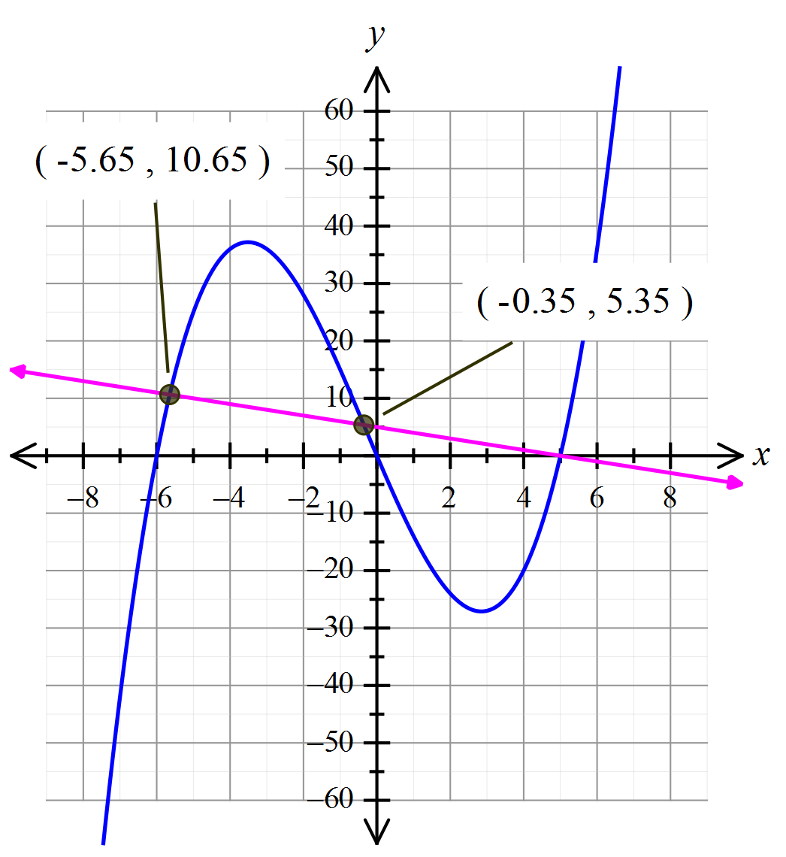
Some considerations/hints:
- Area can’t be negative
- Explore finding the area using both programs and in two separate sections as well as in total
- What happens to the sum of area slices once the functions “cross-over”?
- What conclusions can you draw about how the programs work?
- Can you suggest any ways to improve the program routine?

Areas between functions
Extended investigation Part 2: In-class validation (34 marks)

Question 1 (13 marks)

Consider the graphs of 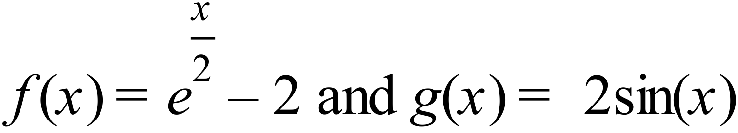
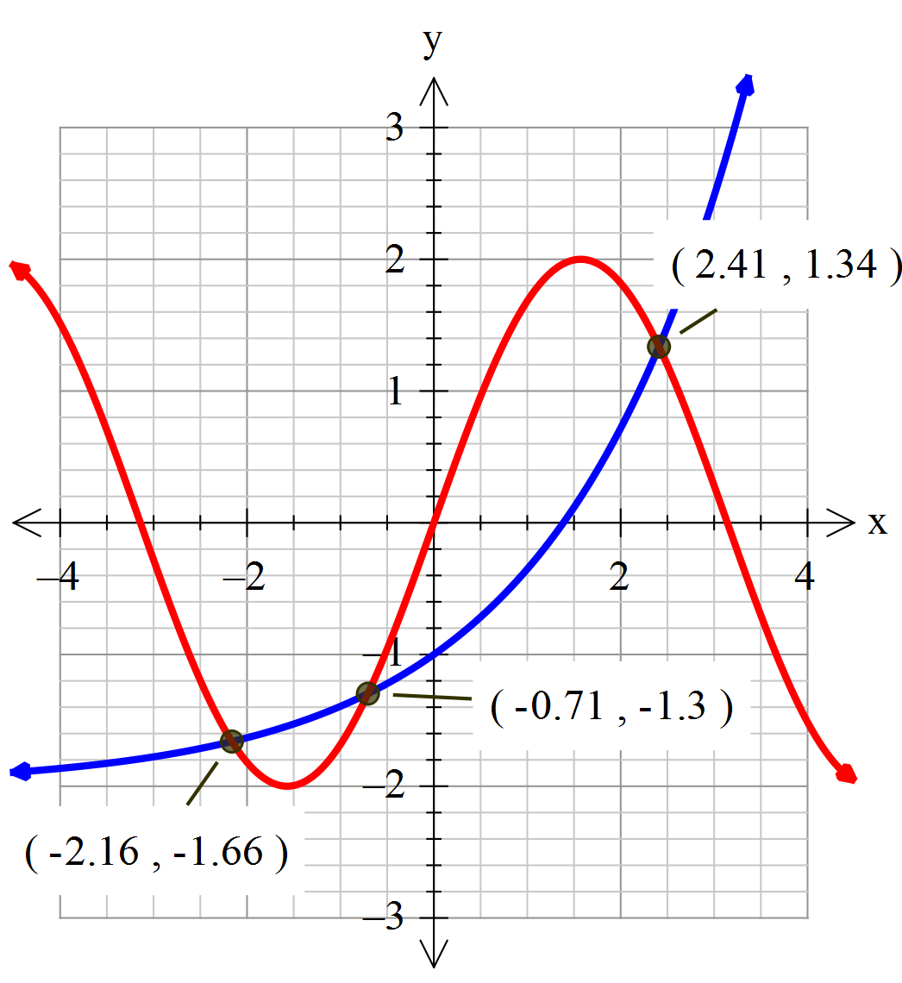

- Use the method of adding ‘slices’ to determine the area between the two curves from . Indicate the number of ‘slices used and the total area found. (2 marks)

- Use the method of adding ‘slices’ to determine the area between the two curves from . Indicate the number of ‘slices used and the total area found. (2 marks)

- Use the method of adding ‘slices’ to determine the area between the two curves from . Indicate the number of ‘slices used and the total area found. (2 marks)

Let 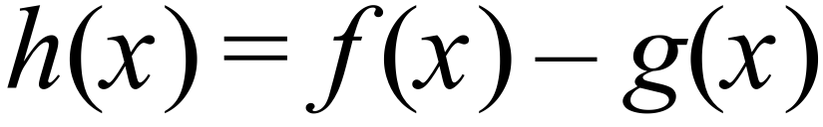 .
- Determine 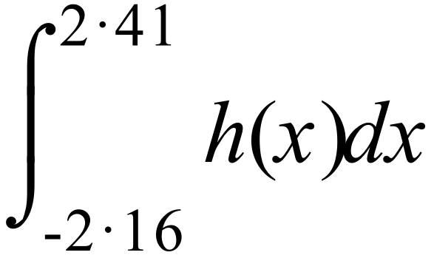 (2 marks)

Let 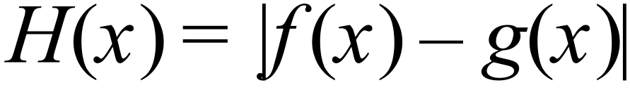

- Evaluate 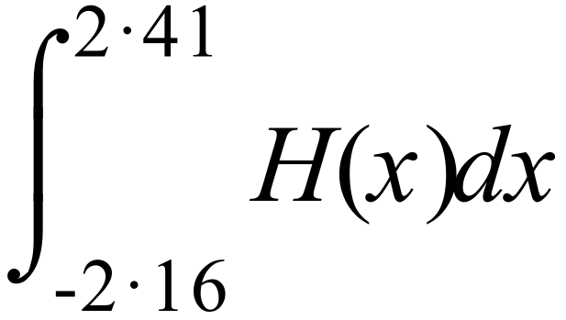 (2 marks)

- Explain why the values in parts (d) and (e) are different, making reference to area and to the results of parts (a) to (c). (3 marks)

Question 2 (11 marks)

Consider the function 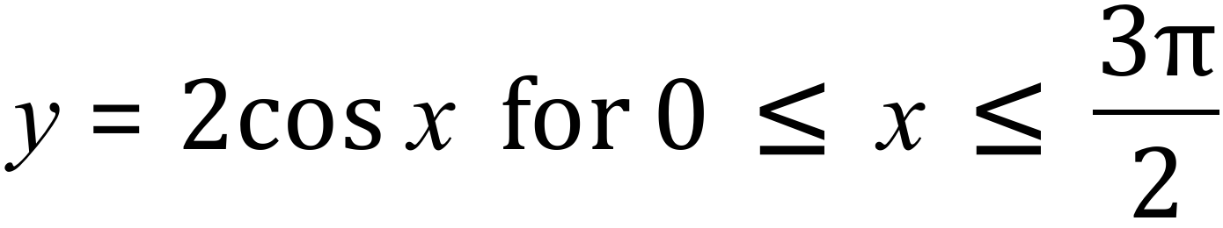 .
- Draw a sketch of the curve on the set of axes provided below. (2 marks)
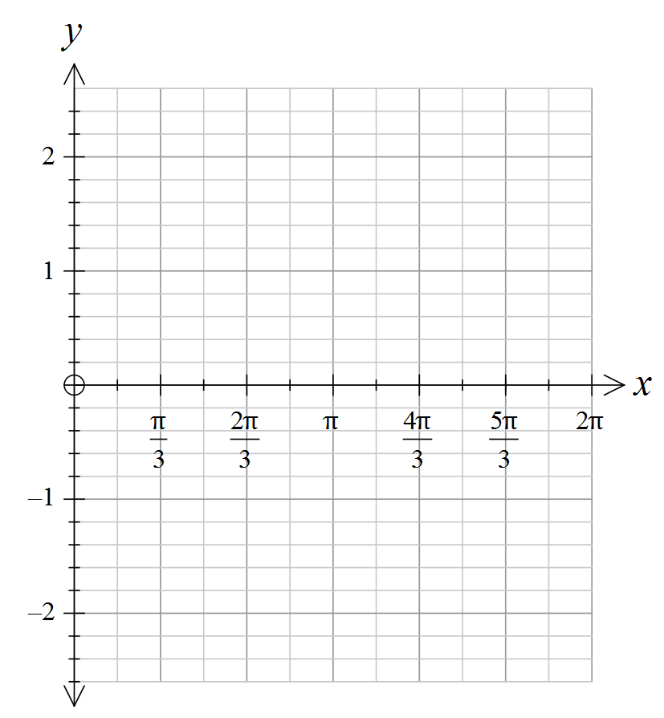

- Given that the area between the curve y = 2 cos x and x– axis for 0 $≤$ x $≤$ $\frac{π}{2}$
is 2 units², predict the area between the curve and x– axis for 0 $≤$ x $≤$ $\frac{3π}{2}$
(2 marks)

(c) Complete the table below using 9 appropriate partitions (slices) over the given
domain and determine the area between the curve y = 2 cos x and x– axis
for 0 $≤$ x $≤$ $\frac{3π}{2}$ , by adding the areas of each of the ‘trapeziums’ so formed.
(4 marks)

[Hint: you may find it helpful to use one of the programs from the preparation activity with the second function defined to be]

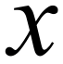 | 0 | 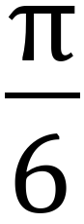 | 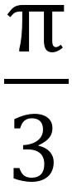 | 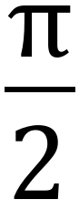 | 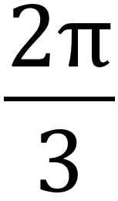 | 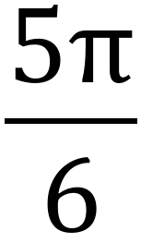 | 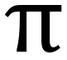 |  |  | 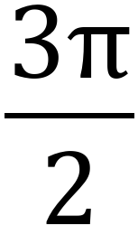
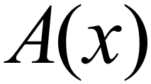 | 0 | 0.997 | 1.712

(d) Comment on any differences between the area you predicted in part (b) and the area you calculated in part (c). Provide an explanation for any differences by comparing the two methods of determining the area. (3 marks)

End of questions

Areas between functions
Extended investigation Part 1: Preparation activity
Solutions

Activity one
Solution
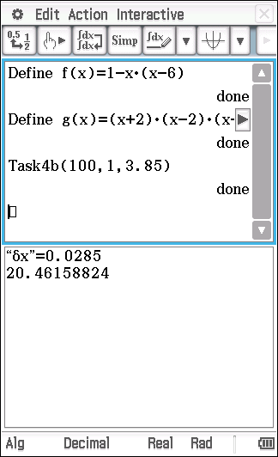
The area between the curve approaches 20.462 (to 3 decimal places) which is closer to the area determined by evaluating the exact integral (which is 20.464 to 3 decimal places).

Activity two
Solution
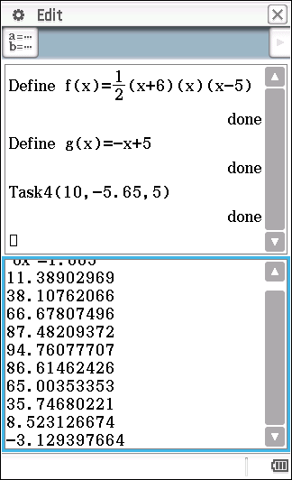
Firstly, attempting to find the area in one go (over the domain -5.65 to 5) using the program Task 4(10, -5.65, 6).

As can be seen the sum of the slices of area (total area) increases and then decreases, finally being negative
This is because the difference becomes negative, once the graphs cross.

So by finding the area in two separate parts, we will avoid this problem.
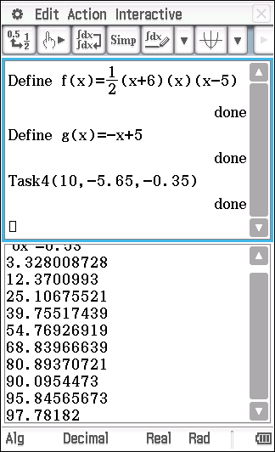
Part A of the area required, can be found by summing the slices from -5.65 to -0.35.
Part B can be found by summing from -0.35 to 5 BUT, we also need to adjust the program so that the calculation of the area of each slice is not negative.
Note that for part A over the domain from -5.65 to -0.35.
So we need to adjust the program so that for part B the calculation of the area of each slice is positive. We can do this by using in the calculation of the area of each slice (since for the domain -0.35 to 5.

Hence the program would like that shown below, as is the output.
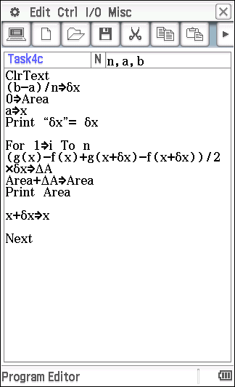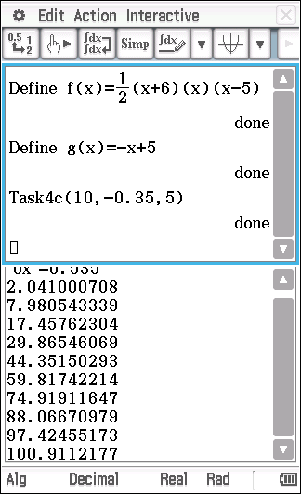
So the area required is 97.782 + 100.911 = 198.693 units² (to 3 decimal places).

Areas between functions
Solutions and marking key Part 2: In-class validation

Question 1 (a)
Solution
Using the program from the preparation activity,
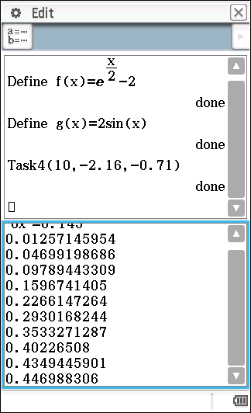
Using 10 partitions, the area is approximately 0.447.
(Using 20 partitions gives the area as 0.450)
Mathematical behaviours | Marks
- provides an area consistent with the number of partitions used | 2

Question 1 (b)
Solution
Using the program from the preparation activity, and switching the definitions of the two functions (since is greater than over this domain)
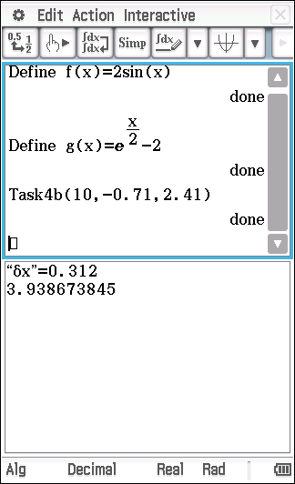

Using 10 partitions, the area is approximately 3.939.
(Using 20 partitions gives the area as 3.965).

The program ‘Task4b’ was used here, which only prints the total area of adding the slices over the specified domain.
Mathematical behaviours | Marks
- indicates the need to switch the functions (or to adjust the program) so that the area is positive  - provides an area consistent with the number of partitions used | 1  1

Question 1 (c)
Solution
If one of the programs ‘Task4 or Task4b’ is used, the result will be incorrect irrespective of which function is used.
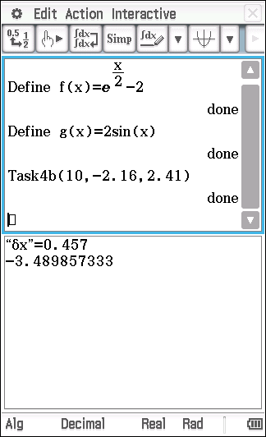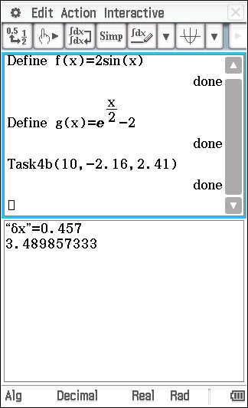

The correct result is arrived at by simply adding the two areas found in parts (a) and (b).
Area = 0.447+3.393=4.386 if 10 partitions are used (or 4.415 if 20 partitions are used)

Mathematical behaviours | Marks
- indicates the need to add the two areas found in parts (a) and (b)  - provides an area consistent with the number of partitions used | 1  1

Question 1 (d)
Solution | Mathematical behaviours | Marks
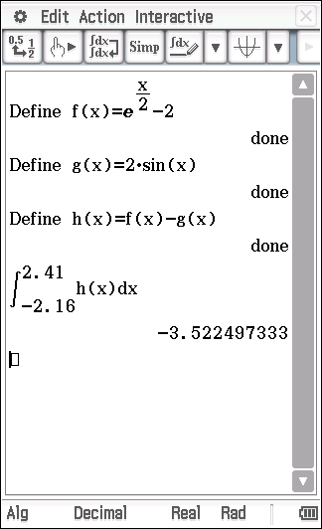 | - evaluates the required integral correctly | 2

Question 1 (e)
Solution | Mathematical behaviours | Marks
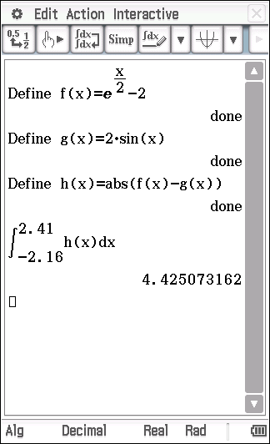 | - evaluates the required integral correctly | 2

Question 1 (f)
Solution
The integral in part (d) is equivalent to the difference of the two areas formed between the two curves, while the integral in part (e) is equivalent to the sum of the two areas. Referring to the areas found by adding slices, the integral in part (e) is equivalent to the sum of the areas found in parts (a) and (b) – allowing for use of a finite number of slices and rounding error. Whereas the integral in part (d) is equivalent to the difference of the two area – allowing for the use of a finite number of slices and rounding error.
Mathematical behaviours | Marks
- indicates integral in part (d) is the difference of the two areas  - indicates integral in part (d) is the sum of the two areas  - make a reasonable attempt at linking the integral result to the sum of the slices method used in parts (a) to (c) | 1  1  1

Question 2 (a)
Solution
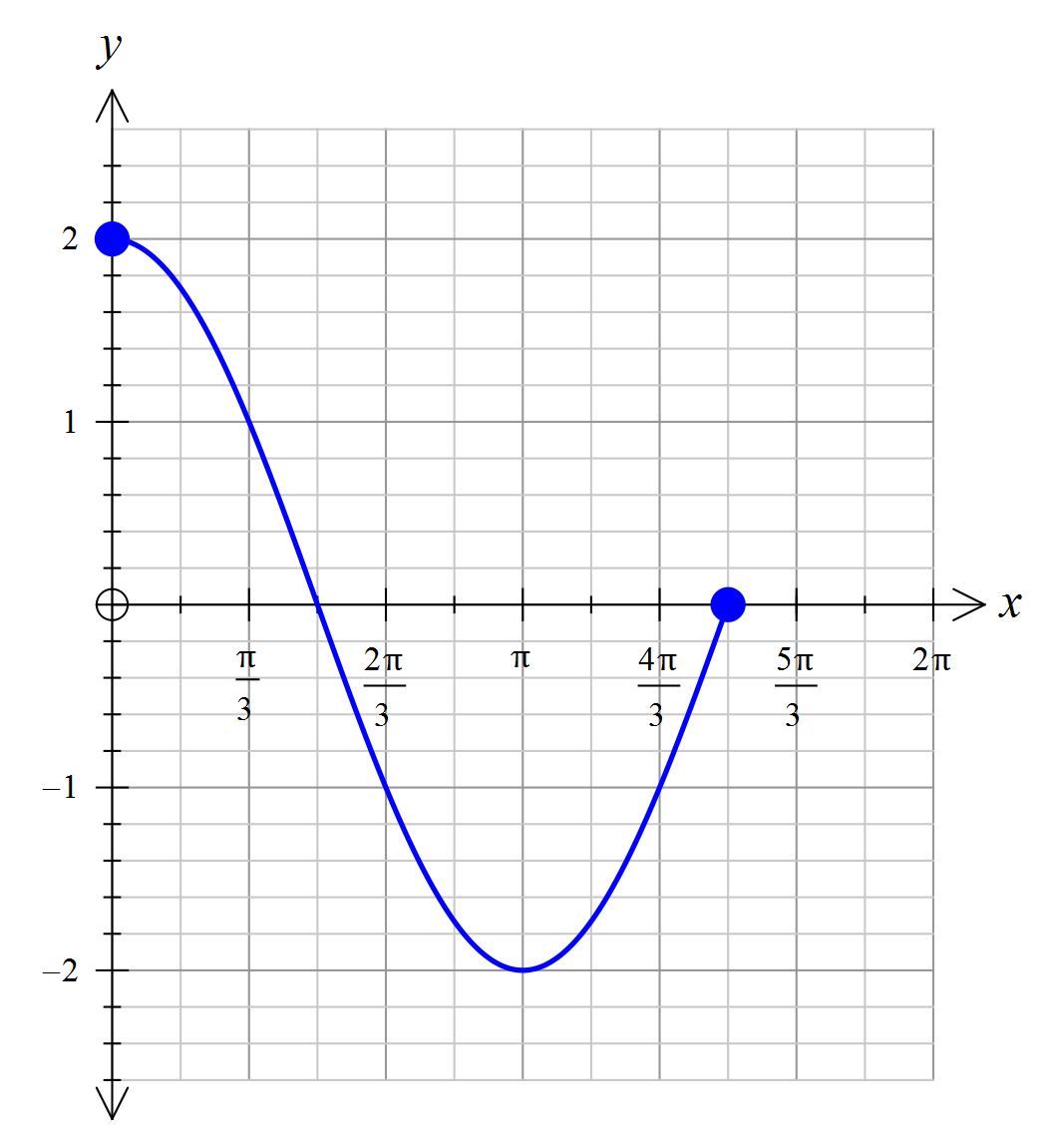
Mathematical behaviours | Marks
Draws the graph showing  - correct intercepts and domain  - ‘good’ shape and turning points | 1  1

Question 2 (b)
Solution
By symmetry of the curve, the area for will be 3 times
the area for square units
Mathematical behaviours | Marks
- states the correct area  - gives an explanatory statement for how the area was determined | 1  1

Question 2 (c)
Solution
Using the program Task4(9,0, ) from the preparation activity, the table can easily be completed.
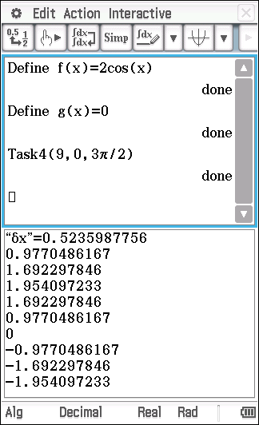

 | 0 |  |  |  |  |  |  | 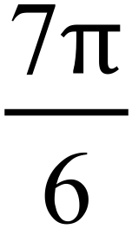 | 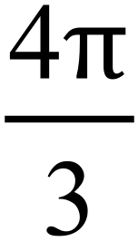 | 
 | 0 | 0.977 | 1.692 | 1.954 | 1.692 | 0.977 | 0.0 | -0.98 | -1.70 | -1.96

Negative values of 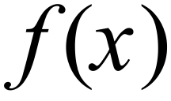 will result in negative values for which is obviously not what we want, as area cannot not be negative.
One way to overcome this is to split the problem into two parts.
Firstly, run Task4(3,0, ) and record the result. Then run an adjusted Task 4 using n = 6 over the domain  to 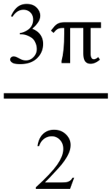 (eg. Task4b (6, ).

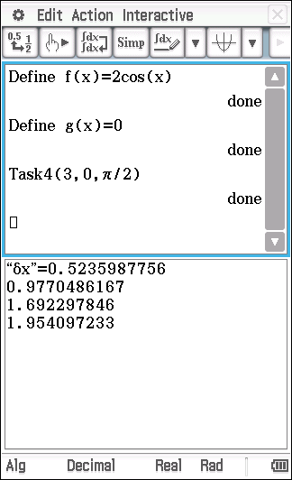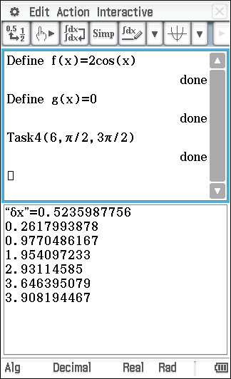
So, the area from 0 to is 1.954 (3 decimal places).
Next, change the print command in the program to Print - Area and re-run the adjusted Task4(6, ,) and add the two results.
1.954+3.908=5.862.
Of courses the number of partitions used here is rather small, so the area calculated is likely to be considerably under estimated. Why?

Mathematical behaviours | Marks
- identifies the need to divide the area into two parts  - correctly determines the area of each part  - determines the correct value of  - provides an appropriate interpretation of the negative values for | 1  1  1  1

Question 2 (d)
Solution
The area of 6 units² found in part (b) was done by using the symmetry of the curve, having been given an exact area under the curve for part of the domain. This compares favourably with 5.862 units² found in part (c). which was calculated by summing 9 slices (or partitions).
The answer in part (c) would be expected to be slightly smaller due to the use of the sum of ‘trapeziums’ to determine the area under a curve which is ‘concave down’. Each partition is slightly smaller than the actual area under the curve over the domain.
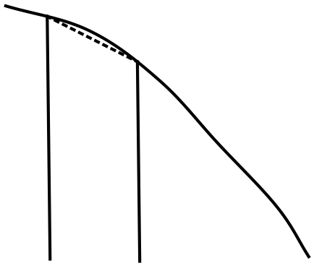

Also the use of only 9 partitions covering both areas means that a significant error is made.
The use of 30 partitions results in an area of 5.988 units² which is much closer to 6.
Mathematical behaviours | Marks
- provides a reasonable explanation of the two methods used to calculate the area  Gives an explanatory statement about the difference,  - taking into account the error due to the concavity of the curve  - the small number of partitions used | 1  1  1

TASK 5: Areas between graphs and the x-axis

In-class Investigation

Unit 3

Topic 3.2: Integrals

Course-related information

The concepts included in this investigation relate to the following dot points within the WA Mathematics Methods syllabus:
3.2.10 examine the area problem and use sums of the form $\sum_{i}{f\left(x_{i}\right) δx_{i}}$ to estimate the area under the curve $y=f(x)$
3.2.15 examine the concept of the signed area function $F\left(x\right)=\int_{a}^{x}{f\left(t\right)dt}$
    - calculate the area under a curve

The ability to choose and use appropriate technology to enhance and extend concept development are also incorporated within some of the items.

Background information
Students should be given this task before integration skills or concepts have been taught in class, although they will need to be familiar with the idea of anti-differentiation covered as part of the Year 11 Methods course and have covered the differentiation of trigonometric functions.

Task conditions
Students will need to have access to a CAS calculator for this in-class investigation task.

Areas between graphs and the x-axis
In-class Investigation 36 marks
The aim of this investigation is to look for a method of finding areas between curves and the x-axis. For example, what is the area (exactly) shaded in the diagram below, where 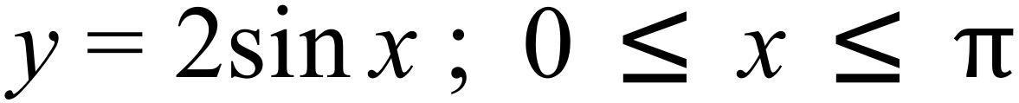
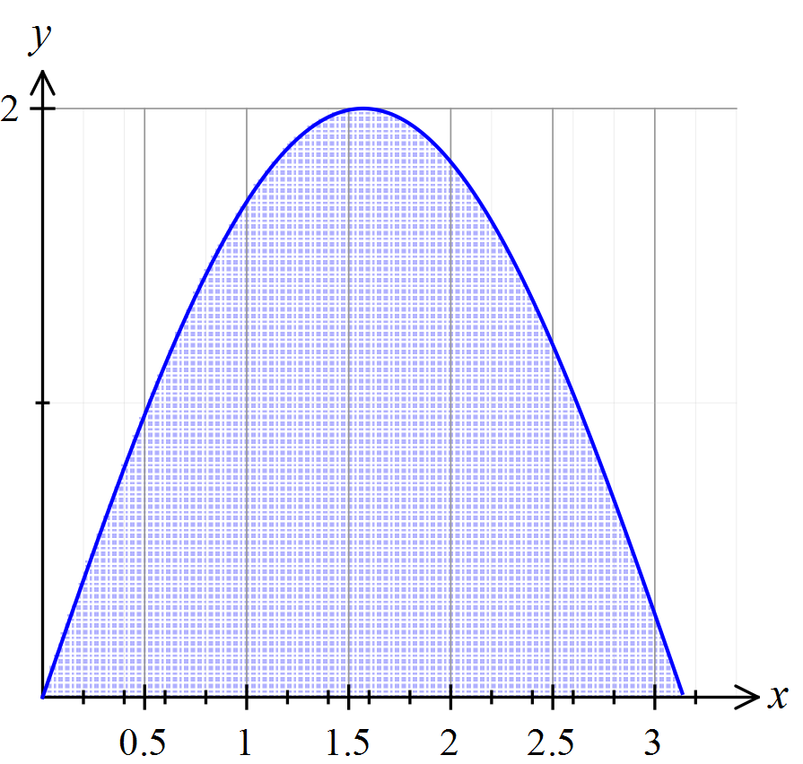
Let us start by doing an easier problem first.
Question 1 (8 marks)
Consider the graph of the function .
Define a function 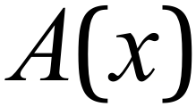 to be the area bounded by the ‘curve’ 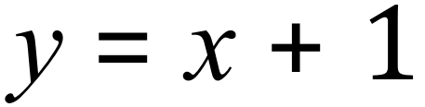and the
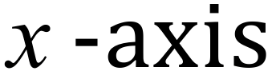 between 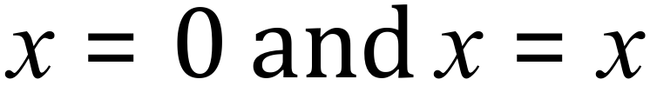 .
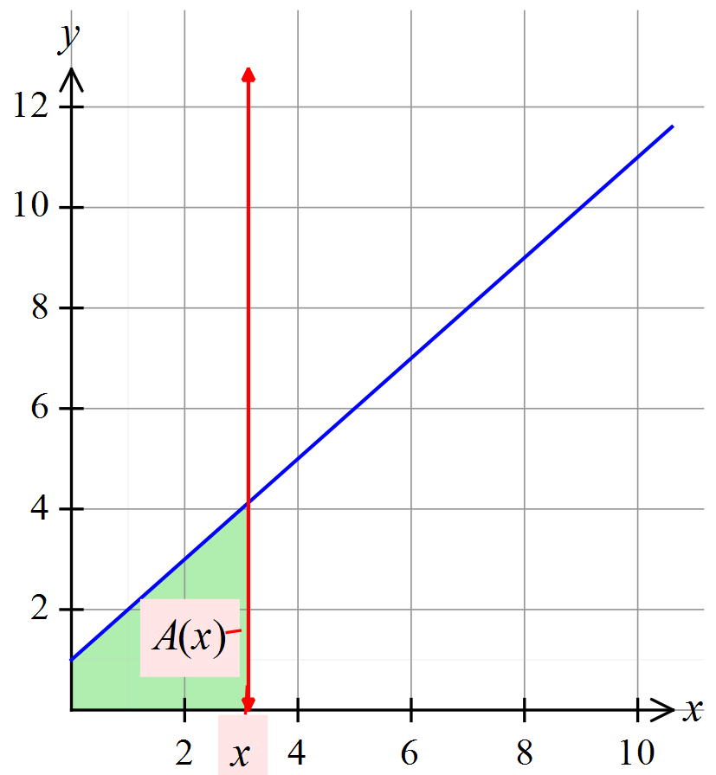
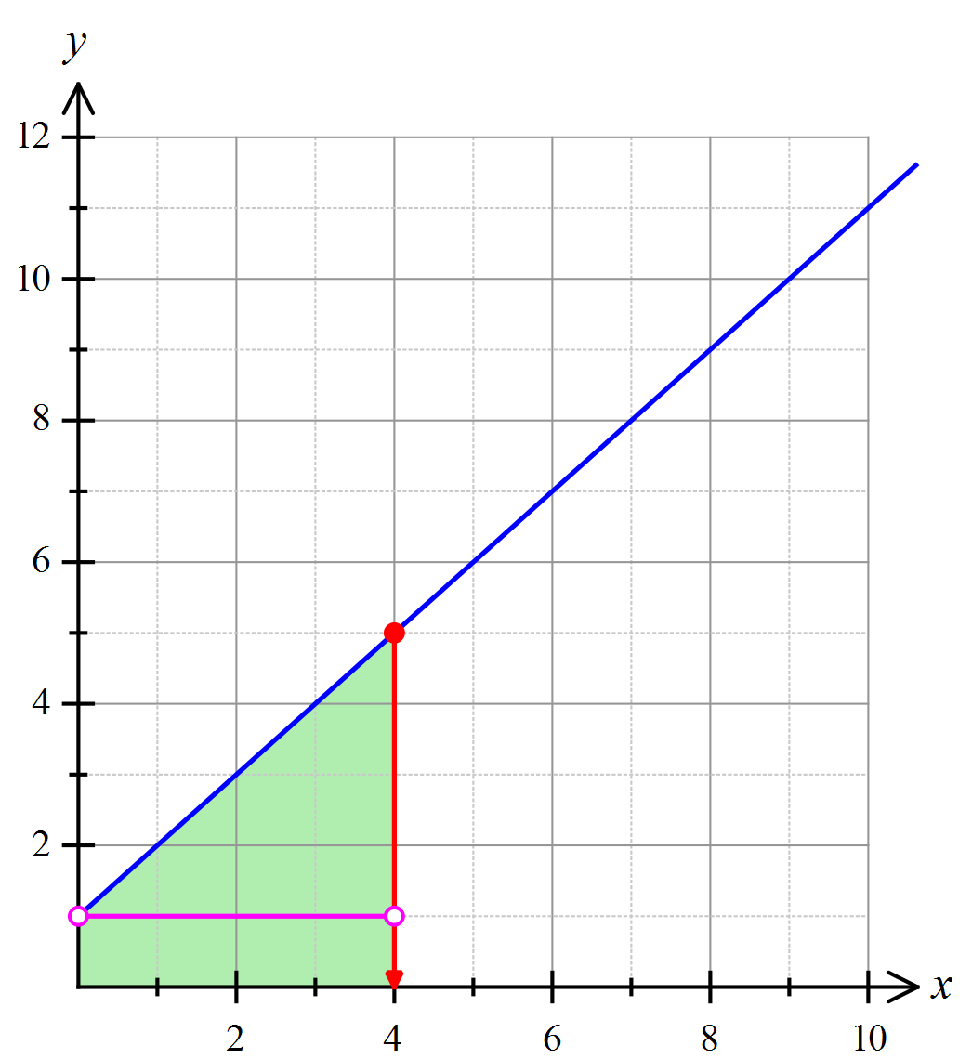For example, the area
= area of a 3 x 1 rectangle plus the area of 3 x 3 right triangle. So,

And,

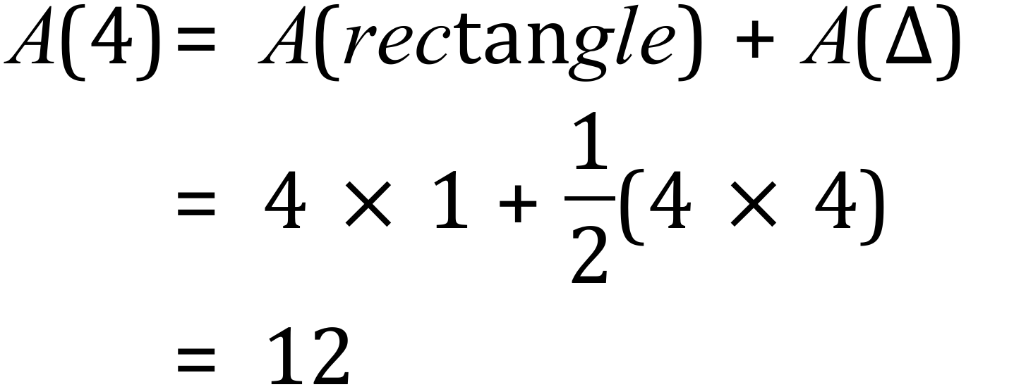

- Complete the table below: (3 marks)

 | 1 | 2 | 3 | 4 | 5 | 6 | 7 | 8
 | 1.5 | 4 | 7.5 | 12 | 17.5

- State a general rule for  explaining how you arrived at it. (2 marks)

- Consider the relationship between  and 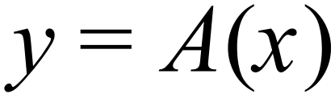
Stating how one could be derived  and also how could be derived from . (3 marks)

Question 2 (8 marks)
Now repeat this exercise for the linear function.
- 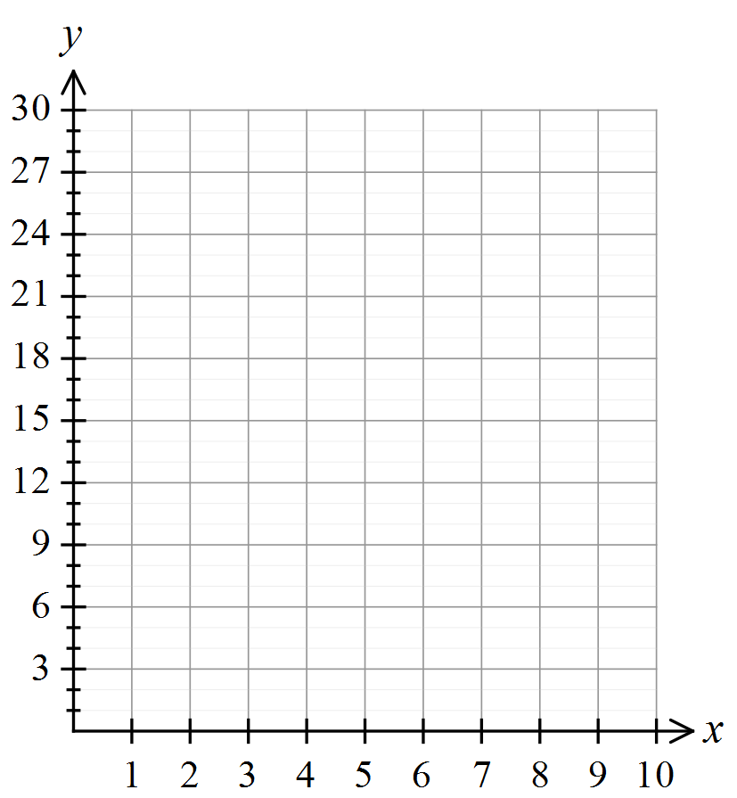Draw a sketch of the function on the axes provided. (2 marks)

- Complete the table of values for  at each respective point , indicating how you calculated at least one of the areas,  (2 marks)
 | 1 | 2 | 3 | 4 | 5 | 6 | 7 | 8
 | 3.5 | 10 |  |  | 47.5 | 68 |  | 112

- State a general rule for indicating/explaining how it was arrived at, noting any connection between and  considering how each could be derived from the other. (4 marks)

Now let us go back to the original example involving 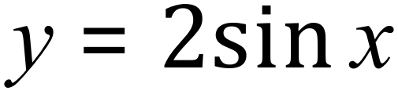 and find an approximation for the area under the curve in this case. If we ‘partition’ (divide or cut up into small parts or pieces) the area in question into a series of ‘trapeziums’, we can add these up to get a rough approximation for the area required. Consider the diagram below.
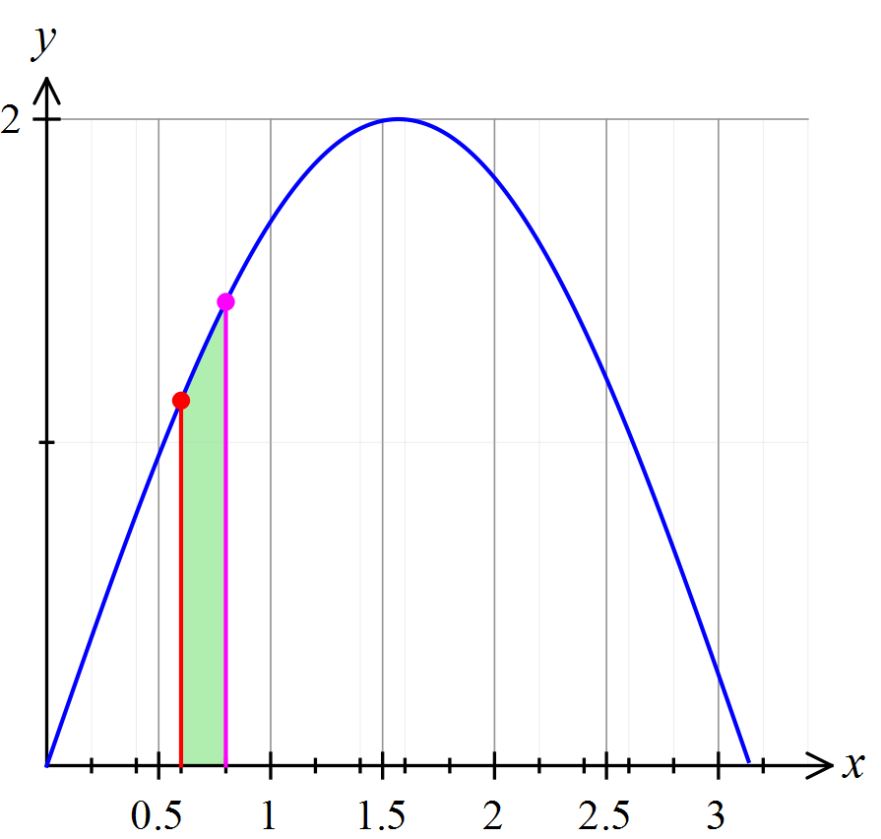
If the partitions are ‘small enough’, we can reasonably assume that the area of the shaded shape will approximately be the same as that of a ‘trapezium’ of width 0.2 and length of parallel sides,respectively. Hence the area of the shaded ‘trapezium’ will be
Or on a calculator…
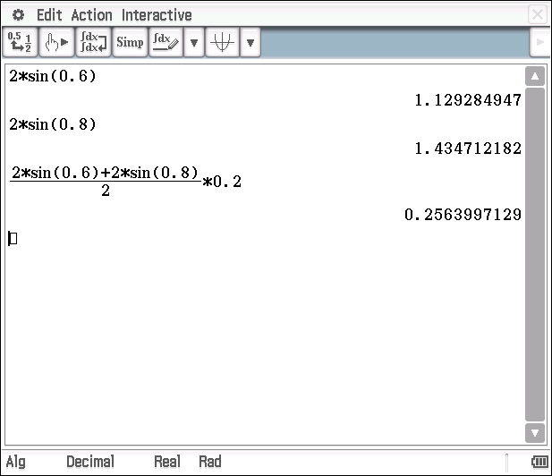
Let us defined  to be the total area bounded by the curve 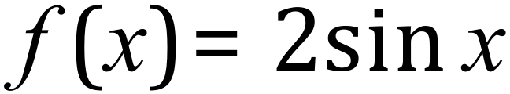 and the 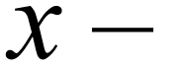 axis on the interval 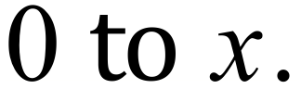

This is illustrated in the diagram below.
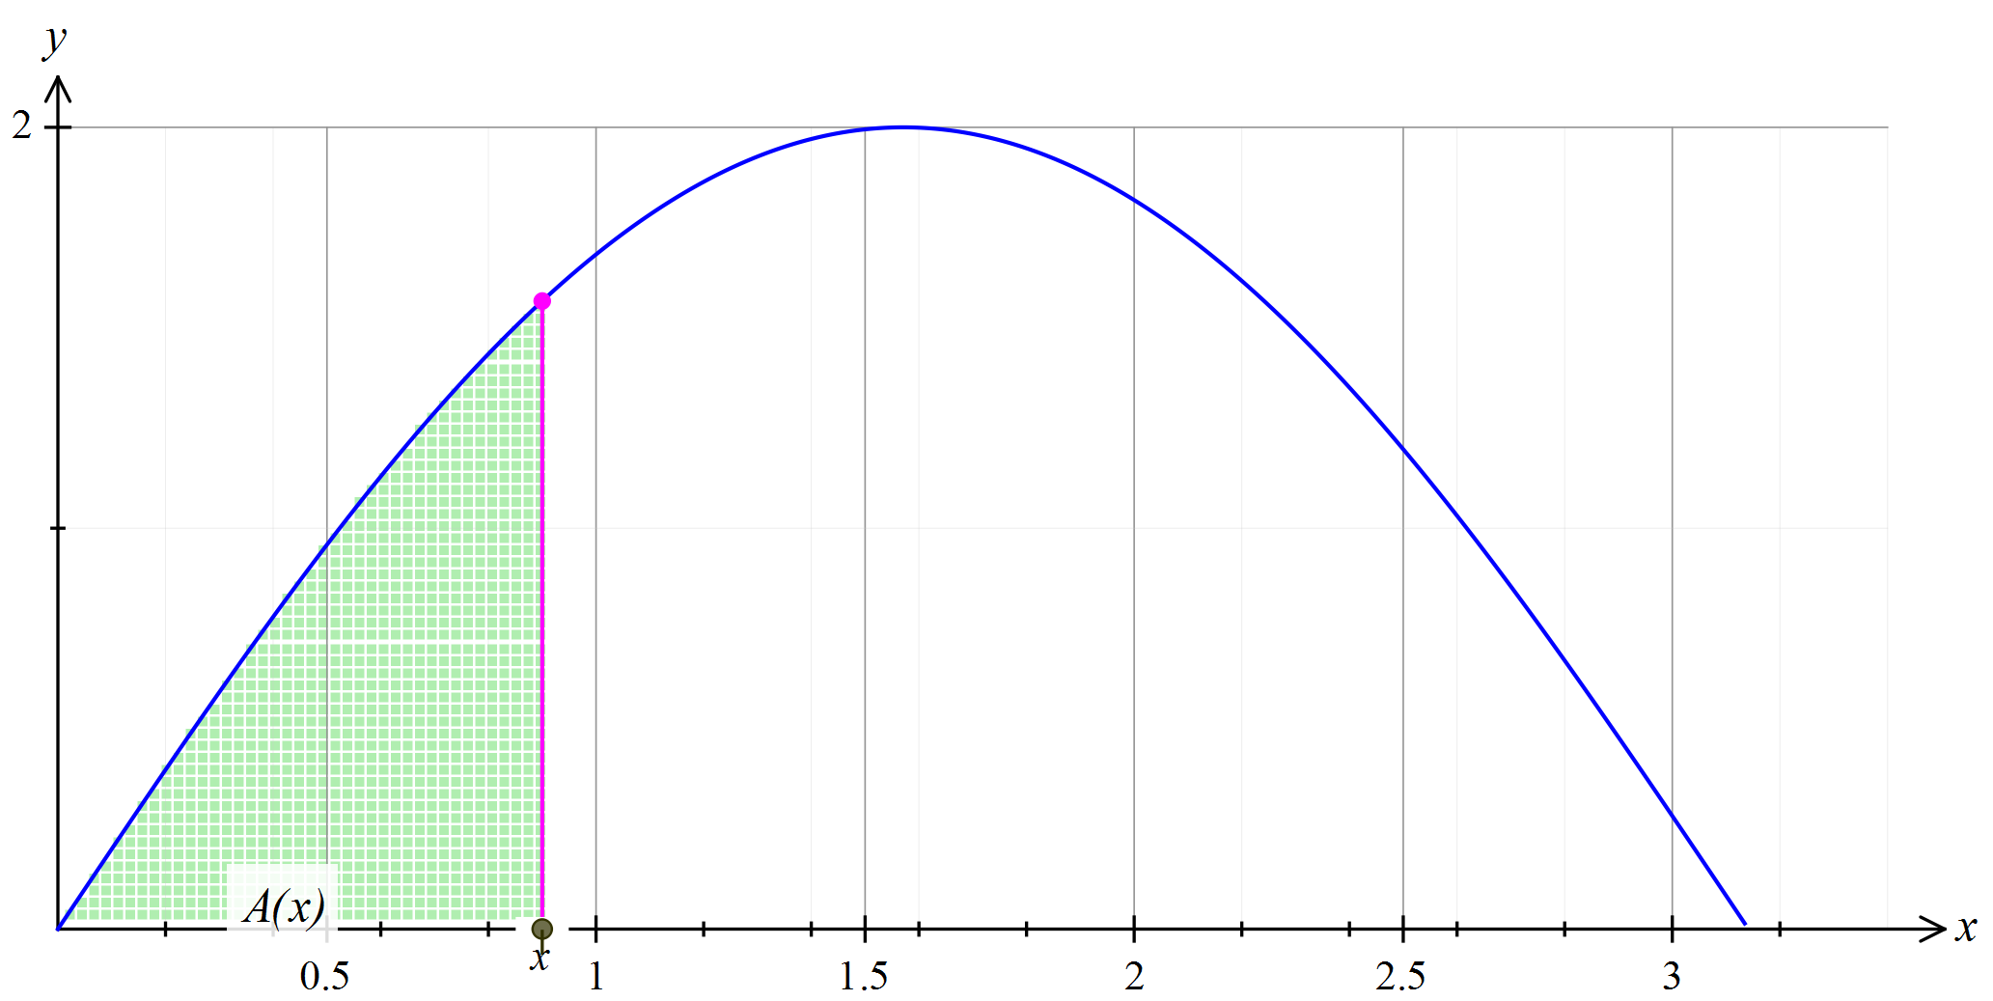
Question 3 (11 marks)

- Use your calculator to complete the following table: (4 marks)

 | 0 | 0.2 | 0.4 | 0.6 | 0.8 | 1 | 1.2 | 1.4 | 1.6
 |  | 0.040 | 0.118 | 0.191 | 0.256 | 0.312 |  | 0.383 | 0.397
 | 0 | 0.040 | 0.157 | 0.348 | 0.604 | 0.916 |  | 1.655 | 2.052
* - represents the area of each partition (or slice)

 | 1.8 | 2.0 | 2.2 | 2.4 | 2.6 | 2.8 | 3.0 | $$π$$
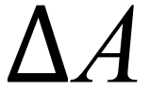 | 0.394 | 0.377 |  |  | 0.238 | 0.170 | 0.095 | 0.028
 | 2.446 | 2.823 |  |  | 3.701 | 3.871 | 3.967 | 3.995

- Use your calculations, to state an approximate value for the area underneath
. (2 mark)

An interesting challenge is to try and find an algebraic expression for  within the given domain, 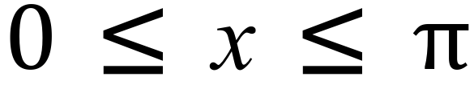.

- Make a generalisation about how  may be related to. You may wish to refer back to your results from questions 1 and 2, to help you with this.
(2 marks)

- Test your generalization for  in part (c) above, by comparing corresponding values from part (b) and explaining any variations or by refining your generalisation. The table below may help. (3 marks)

 | 0 | 0.2 | 0.4 | 0.6 | 0.8 | 1 | 1.2 | 1.4 | 1.6
 | 0 | 0.040 | 0.157 | 0.348 | 0.604 | 0.916 |  | 1.655 | 2.052

Question 4 (9 marks)

- Predict the area under the curve 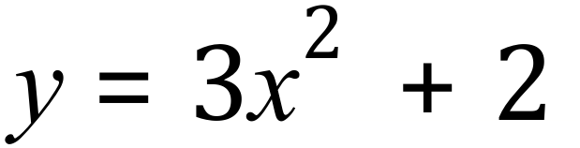 for 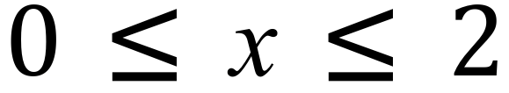 . (3 marks)

- By completing the table below, determine the area under over the domain  using the partition method as per questions 4. You may find it helpful to use a calculator routine (as indicated below) to complete the table of values required. (4 marks)

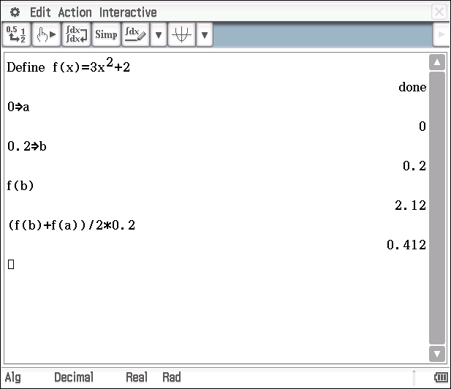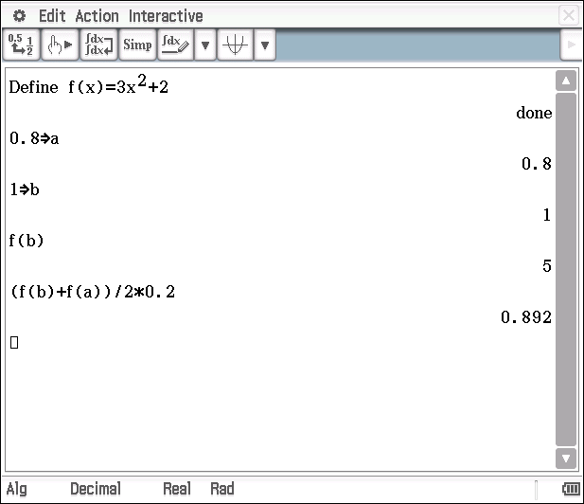

 | 0 | 0.2 | 0.4 | 0.6 | 0.8 | 1 | 1.2 | 1.4 | 1.6 | 1.8 | 2
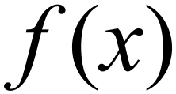 | 0 | 2.12 | 2.48 | 3.08 | 3.92 | 5 |  | 7.88 |  |  | 14
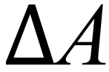 |  | 0.412 | 0.46 | 0.556 | 0.70 | 0.892 |  | 1.42 |  |  | 2.572
 | 0 | 0.412 | 0.872 | 1.428
- Make a statement about how the area found in part 5(b)compares with the area you predicted in 5(a). (2 mark)

Areas between graphs and the x-axis
Solutions and marking key In-class investigation

Question 1 (a)
Solution
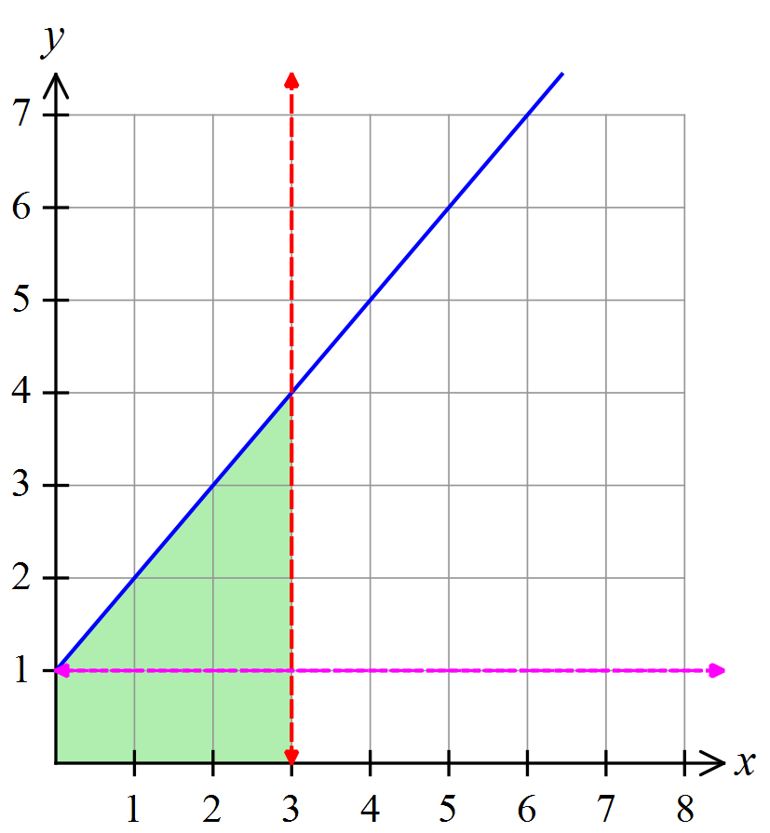

 | 1 | 2 | 3 | 4 | 5 | 6 | 7 | 8
 | 1.5 | 4 | 7.5 | 12 | 17.5 | 24 | 31.5 | 40

Mathematical behaviours | Marks
- indicates understanding of how to calculate the respective areas (either on diagram/graph or numerically)  - correctly calculates one value of  - Calculates all values of correctly | 1  1  1

Question 1 (b)
Solution
, this can be arrived at by noting that the second difference of the sequence in the table is constant (=1) and hence testing for a quadratic expression.
Alternatively, noting that the area of triangle (up to ) = and the area of the rectangle (up to ) =. Summing the two gives the required expression.
Mathematical behaviours | Marks
- Determines a correct expression for  - Indicates a reasonable method of arriving at | 1  1

Question 1 (c)
Solution
Notes that . Hence the anti-derivative of is which is . Thus is the anti-derivative of with the constant of integration equaling 0.
Mathematical behaviours | Marks
- indicates that the derivative of is  - indicates that the anti-derivative of is  - indicates that the constant of integration is 0 (in this case) | 1  1  1

Question 2 (a)
Solution
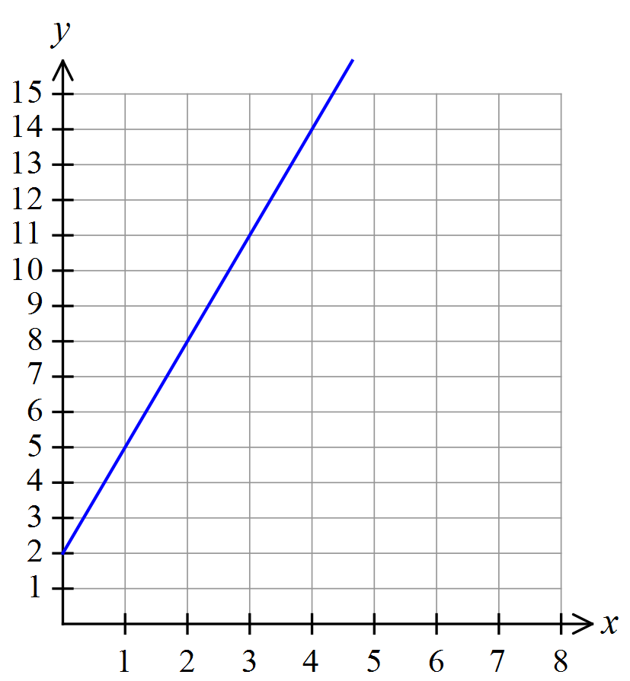

Mathematical behaviours | Marks
Draws a line with the correct  - 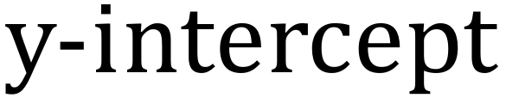  - gradient | 1  1

Question 2 (b)
Solution
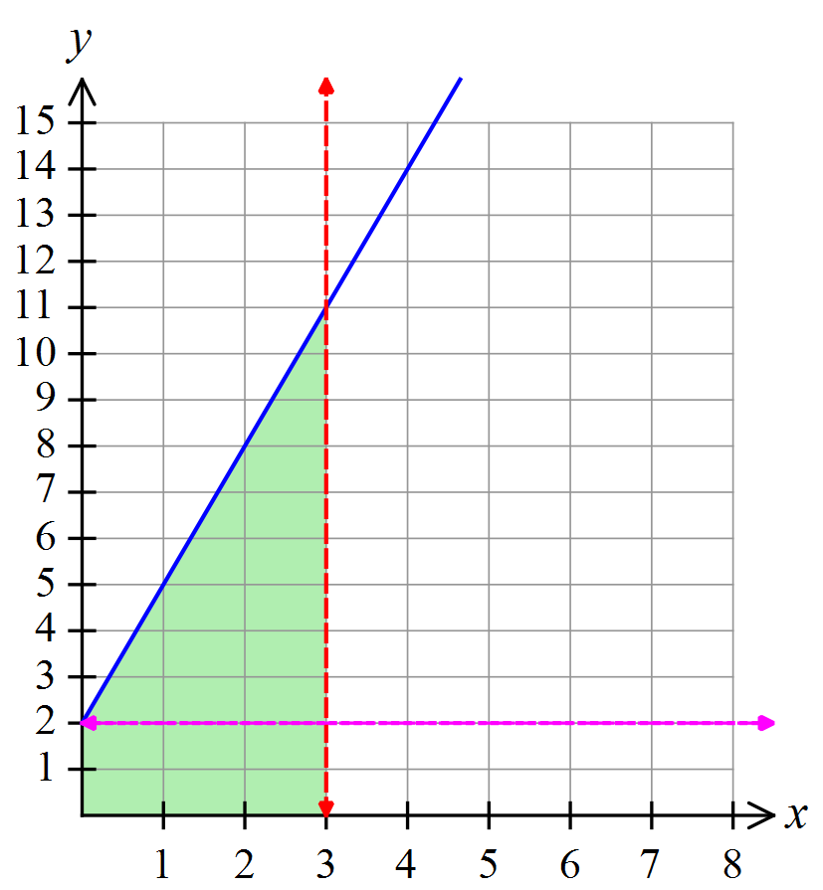The area = area of a 3 x 2
Rectangle plus the area of a 3 x 9
right triangle. So,

 | 1 | 2 | 3 | 4 | 5 | 6 | 7 | 8
 | 3.5 | 10 | 19.5 | 32 | 47.5 | 68 | 87.5 | 112

Mathematical behaviours | Marks
- indicates method of calculation for  - calculates all values of correctly | 1  1

Question 2 (c)
Solution
this can be arrived at by noting that the second difference of the sequence in the table is constant (=3) and hence testing for a quadratic expression.
Alternatively, noting that the area of triangle (up to ) = and the area of the rectangle (up to ) =2. Summing the two gives the required expression.
Also, notes that which is the original function under which the area is being calculated. Hence = where the constant of integration is equal to zero.
Mathematical behaviours | Marks
- Determines a correct expression for  - Provides appropriate working or explanation of how was determined  - Indicates that is an anti-derivative of 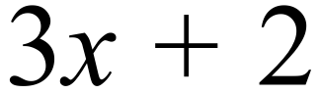  - Make appropriate mention of the constant of integration | 1  1  1  1

Question 3 (a)
Solution
 | 0 | 0.2 | 0.4 | 0.6 | 0.8 | 1 | 1.2 | 1.4 | 1.6
 |  | 0.040 | 0.118 | 0.191 | 0.256 | 0.312 | 0.355 | 0.383 | 0.397
 | 0 | 0.040 | 0.157 | 0.348 | 0.604 | 0.916 | 1.271 | 1.655 | 2.052
* - represents the area of each partition (or slice)

 | 1.8 | 2.0 | 2.2 | 2.4 | 2.6 | 2.8 | 3.0 | $$π$$
 | 0.394 | 0.377 | 0.343 | 0.297 | 0.238 | 0.170 | 0.095 | 0.028
 | 2.446 | 2.823 | 3.166 | 3.463 | 3.701 | 3.871 | 3.967 | 3.995

Mathematical behaviours | Marks
- determines one value of  correctly  - determines all values of  correctly  - determines one value of correctly  - determines all values of correctly | 1  1  1  1

Question 3 (b)
Solution
Mathematical behaviours | Marks
- indicates the need to subtract 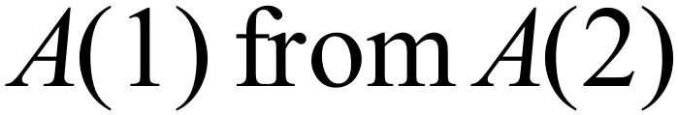  - calculates the required area correctly | 1  1

Question 3 (c)
Solution
Based on questions 1 and 2, it would seem that could be the anti-derivative of . The anti-derivative of is .
Mathematical behaviours | Marks
- indicates a link between the area under the curve and the anti-derivative of the function  - Suggests or +c or +2 | 1  1

Question 3 (d)
Solution
Testing prediction for various values of
 | 0 | 0.2 | 0.4 | 0.6 | 0.8 | 1 | 1.2 | 1.4 | 1.6
 | 0 | 0.04 | 0.157 | 0.348 | 0.604 | 0.916 | 1.271 | 1.655 | 2.052
 | -2 | -1.96 | -1.84 | -1.65 | -1.39 | -1.08 | -0.72 | -0.34 | -0.06
Note that the difference between and is 2 (allowing for rounding)
Thus the area under the curve of is the anti-derivative of where the constant of integration is 2.
Mathematical behaviours | Marks
- infers that a constant of integration other than 0 is required for the connection between the area and the anti-derivative to apply  - completes the table with enough points (correctly) to be able to infer a constant of integration  - determines that the constant of integration needs to be 2 | 1  1  1

Question 4 (a)
Solution
= anti-derivative of 
So would predict the area to 12 square units – based on results of questions 1 and 2 and the fact that the function here is similar (increasing and positive within the domain)
Mathematical behaviours | Marks
- uses the idea of the area being the anti-derivative  - evaluates the anti-derivative at 2 as 12  - acknowledges the possibility of a variation due to the constant of integration | 1  1  1

Question 4 (b)
Solution
 | 0 | 0.2 | 0.4 | 0.6 | 0.8 | 1 | 1.2 | 1.4 | 1.6 | 1.8 | 2
 | 0 | 2.12 | 2.48 | 3.08 | 3.92 | 5 | 6.32 | 7.88 | 9.68 | 11.72 | 14
 |  | 0.412 | 0.46 | 0.556 | 0.70 | 0.892 | 1.132 | 1.42 | 1.756 | 2.14 | 2.572
 | 0 | 0.412 | 0.872 | 1.428 | 2.128 | 3.020 | 4.152 | 5.572 | 7.328 | 9.468 | 12.04

Mathematical behaviours | Marks
- determines the correct value of  - determines the correct value of  - correctly determines more than half of the remaining values  - correctly determines all values | 1  1  1  1

Question 4 (c)
Solution
The predicated area of 12 compares favourably with 12.04 found in part (b).
Would expect the answer in part (b) to be slightly higher due to the use of the sum of
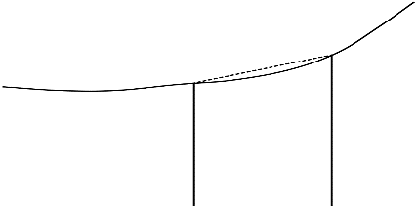
‘trapeziums’ to determine the area. Each partition is slightly larger than the actual area under the curve

Mathematical behaviours | Marks
- any sensible statement of comparison  - an explanatory statement such as why the sum of the partitions is larger than the actual area | 1  1

TASK 6

Investigative questions

Unit 3

Topic 3.2: Integrals

Course-related information
The concepts included in this investigation relate to the following dot points within the WA Mathematics Methods syllabus:
3.2.12 interpret the definite integral $\int_{a}^{b}{f\left(x\right)dx }$as area under the curve $y=f\left(x\right)$ if $f\left(x\right)>0$
    - examine the concept of the signed area function $F\left(x\right)=\int_{a}^{x}{f\left(t\right)dt}$
    - calculate total change by integrating instantaneous or marginal rate of change
    - calculate the area under a curve
3.2.21 determine displacement given velocity in linear motion problems
3.2.22 determine positions given linear acceleration and initial values of position and velocity.
The ability to choose and use appropriate technology to enhance and extend concept development are also incorporated within some of the items.
Background information
Each of the questions provided is stand-alone and may be incorporated into different tasks: it is not intended that they form part of the same assessment task.
Task conditions
These items should be undertaken under test conditions, either as part of a test/examination or as stand-alone items. Student access to a formula sheet and to a graphical/CAS calculator is assumed. The time required to complete each question is left to the discretion of the teacher but the intention is that each question may be completed within 15-20 minutes.

Investigative questions for Topic 3.2
Question 1 (19 marks)
The velocity (in metres/second) of a particle which moves in a straight line, is represented on the graph below.
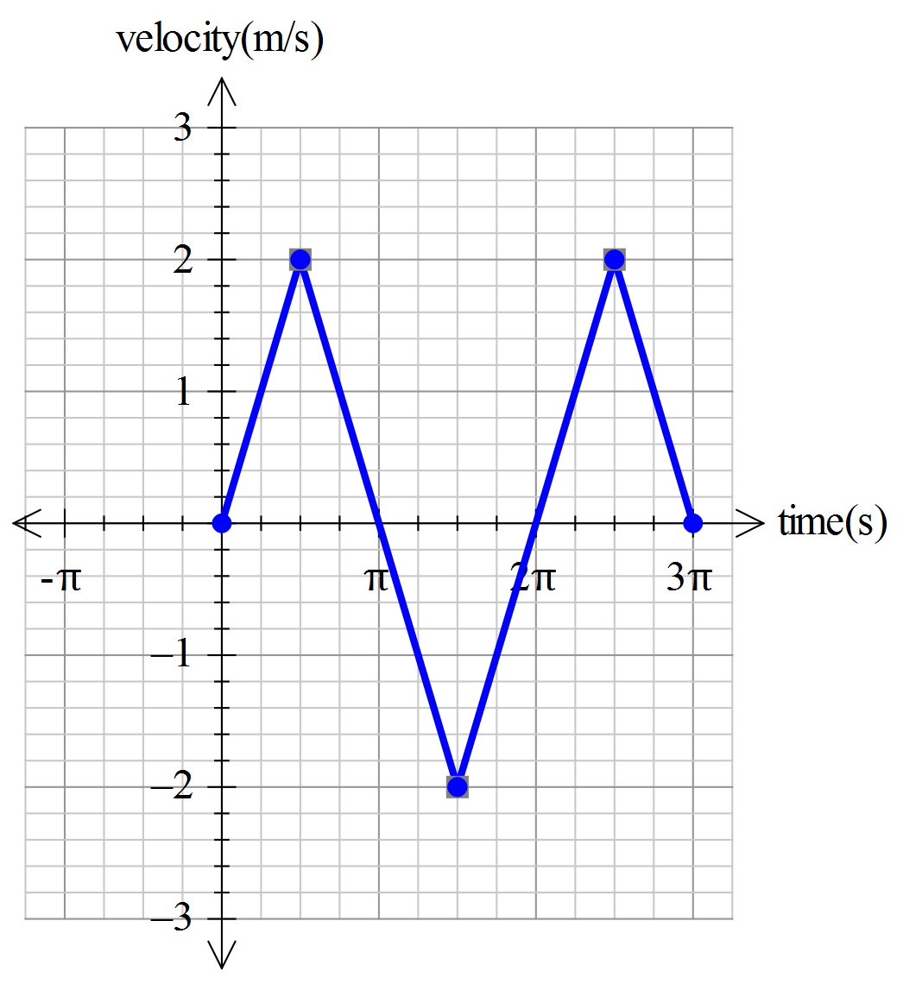
- At what times is the particle stationary? (2 marks)

- Draw a graph to represent the acceleration of the particle over the first seconds.
(4 marks)
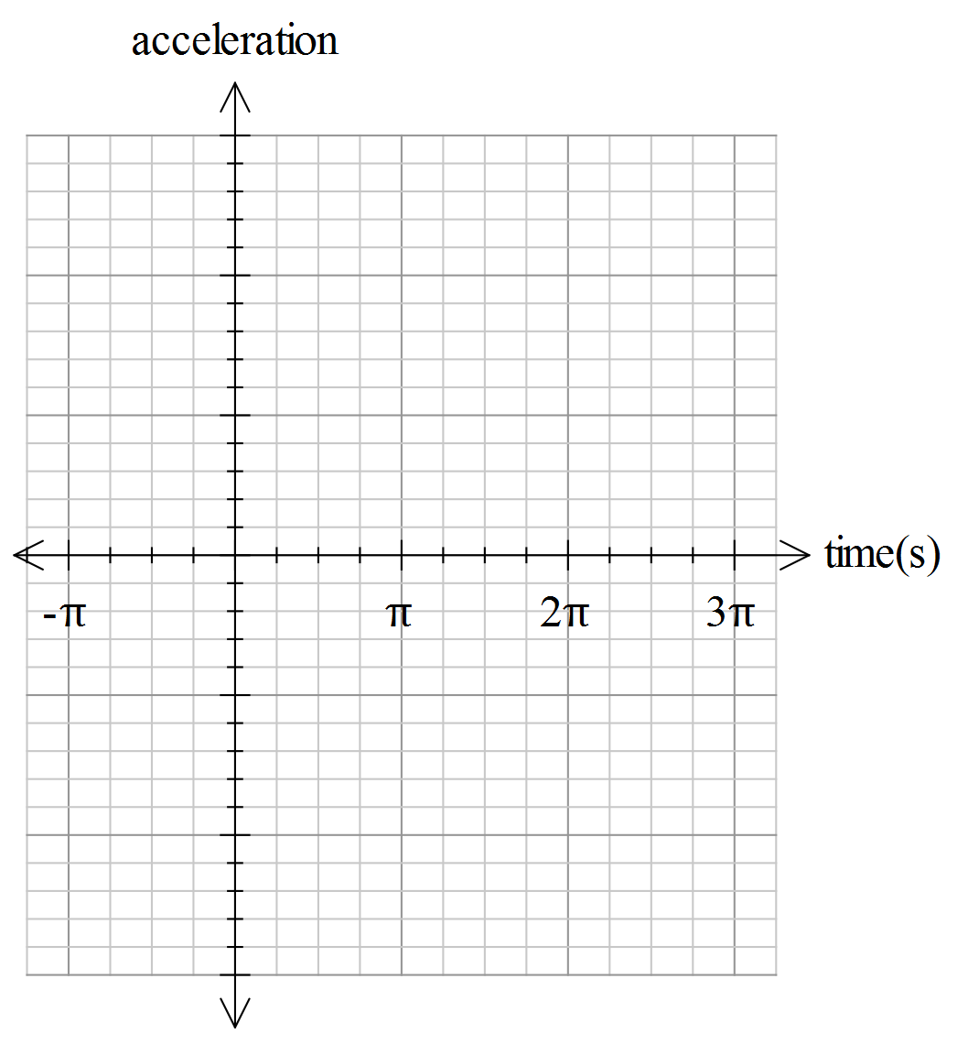
If initially, the particle was located at ,
- determine the position of the particle relative to the starting position, after seconds. (3 marks)

- determine the total distance travelled by the particle over the first seconds and explain how the particle travelled relative to the starting position during this time period.?
(3 marks)

A second particle also travels in a straight line according to the velocity-time graph as shown below.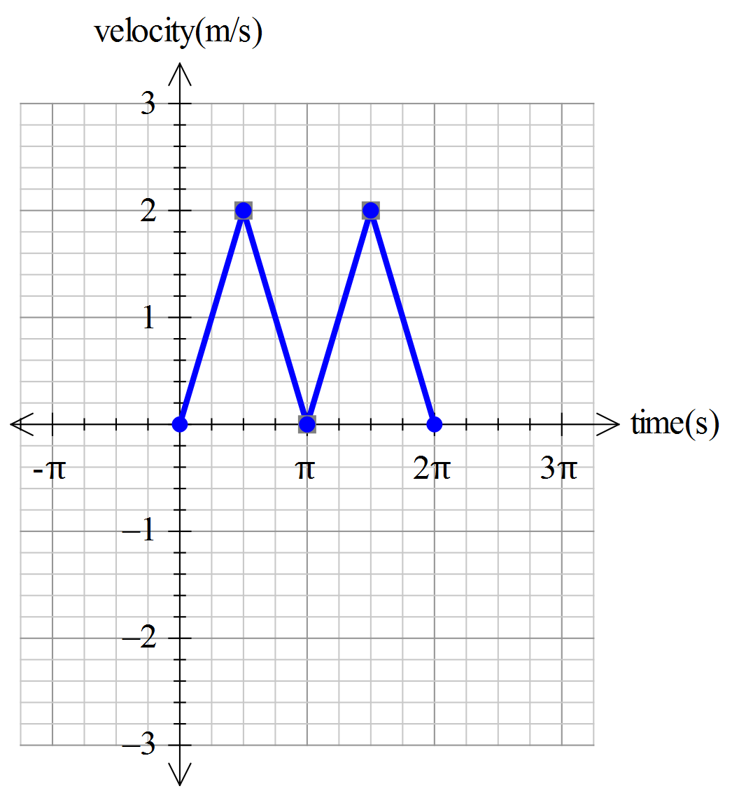

If initially, both particles were located at ,
- determine the distance between the two particles after seconds. (3 marks)

- Briefly, describe the motion of each of the two particles, comparing the direction, velocity and acceleration of the two particles. (4 marks)

Question 2 (17 or 25 marks)
A company manufactures exhaust systems for motor vehicles. The marginal cost (in $’s) is given by graph drawn below where .

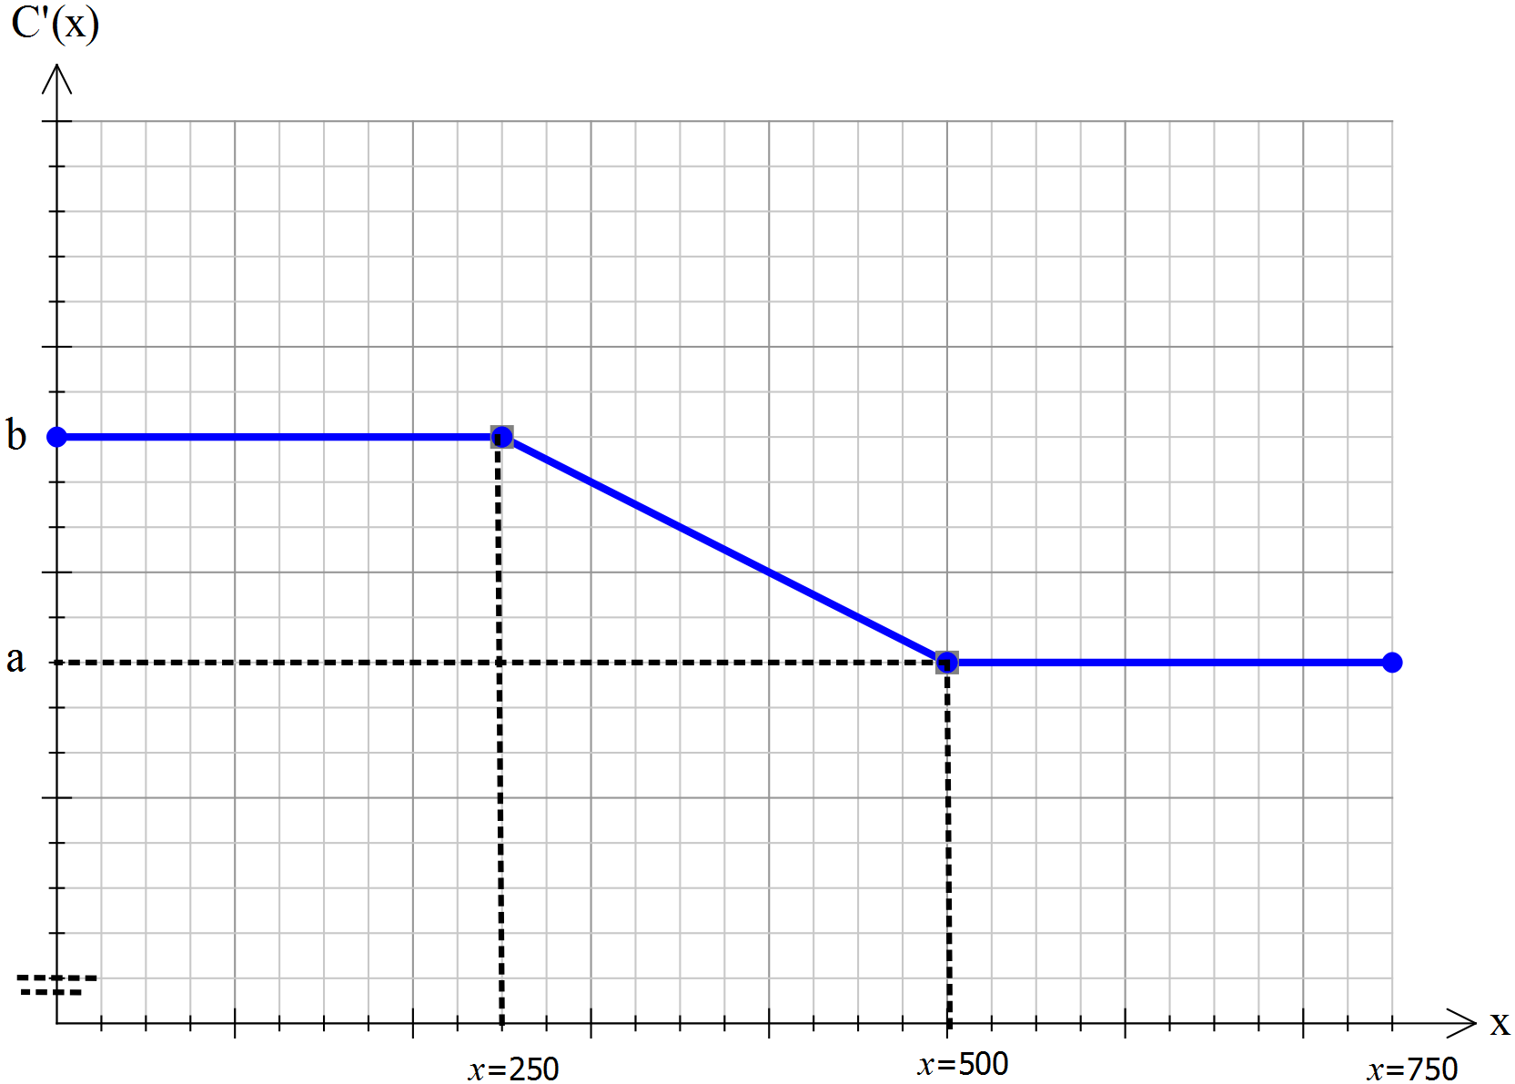

The company has fixed costs of $5000
- Determine the total cost of producing 750 units, in terms of (4 marks)

The company decides to sell its product at $400 per unit.
- Determine an expression for the profit for (3 marks)

If
- Show that for , (10 marks)

Extra part (optional)
If
- Determine a formula to calculate the profit for any between zero and 750. (8 marks)

Solutions and marking key to Investigative Questions
Question 1 (a)
Solution
Particle stationary when the velocity is zero.
ie. at (seconds)
Marking key/mathematical behaviours | marks
- indicates when the particle will be stationary (vel=0)  - states all 4correct times | 1  1

Question 1 (b)
Solution
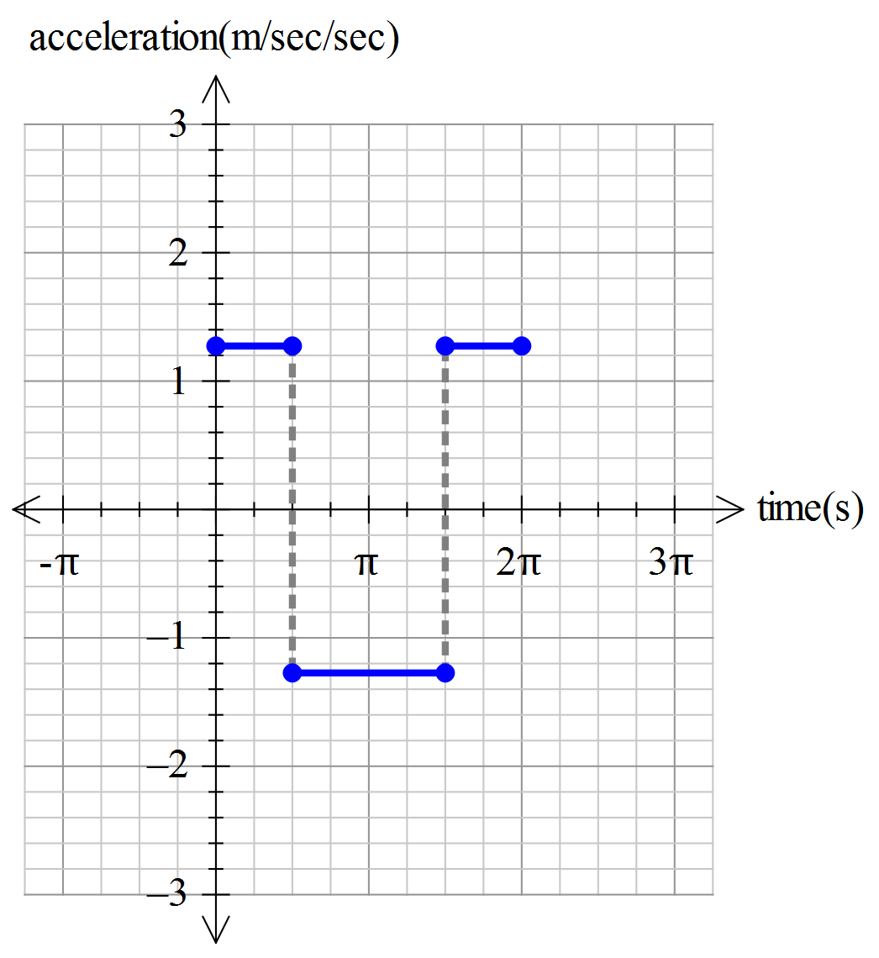
Marking key/mathematical behaviours | marks
- indicates that the acceleration is constant (as the slope of the velocity function is constant) over the appropriate domains  - accruately represents the magnitude of the acceleration  - uses the correct domain  - has an appropriate scale on the y-axis | 1  1  1  1

Question 1 (c)
Solution
Displacement of the particle is given by
Which is equivalent to the area of tringle A in the diagram below, since the area of the other two triangles (B and C below) annihilate each other out.
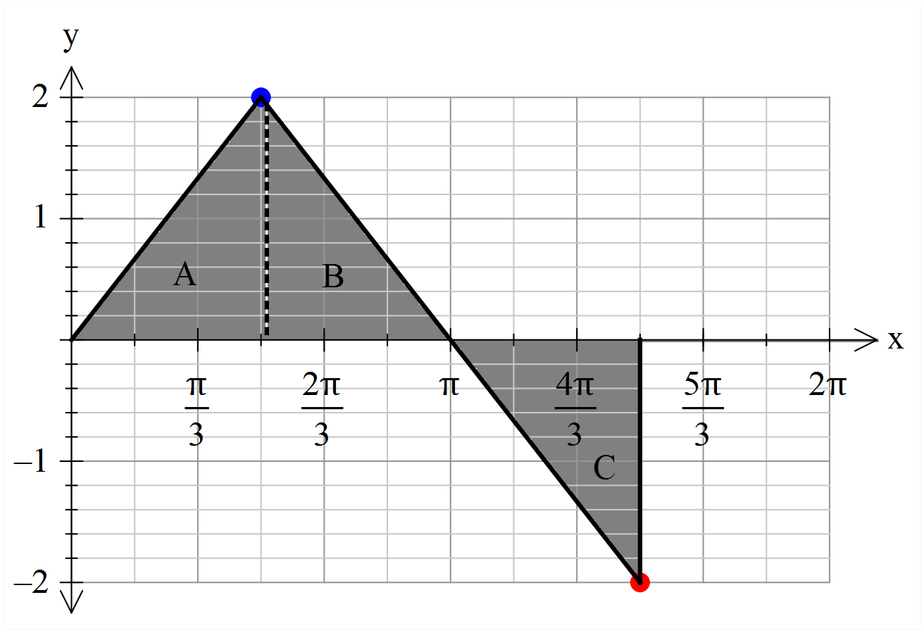
Alternatively,

Marking key/mathematical behaviours | marks
- indicates the need to calculate the area under the ‘curve’ to determine the position  - calculates the area of triangle A correctly  - states the position, applying the sum of the signed areas B and C to equate to 0.  Or  - determines the equation of the velocity as a function of time  - integrates correctly  - states the correct position  (a lot more work for the same marks) | 1  1  1  1  1  1

Question 1 (d)
Solution
Distance travelled by the particle
The particle moves metres in the positive direction and then metres in the negative direction, finishing up metres to the right of the starting position but having travelled metres to arrive there.
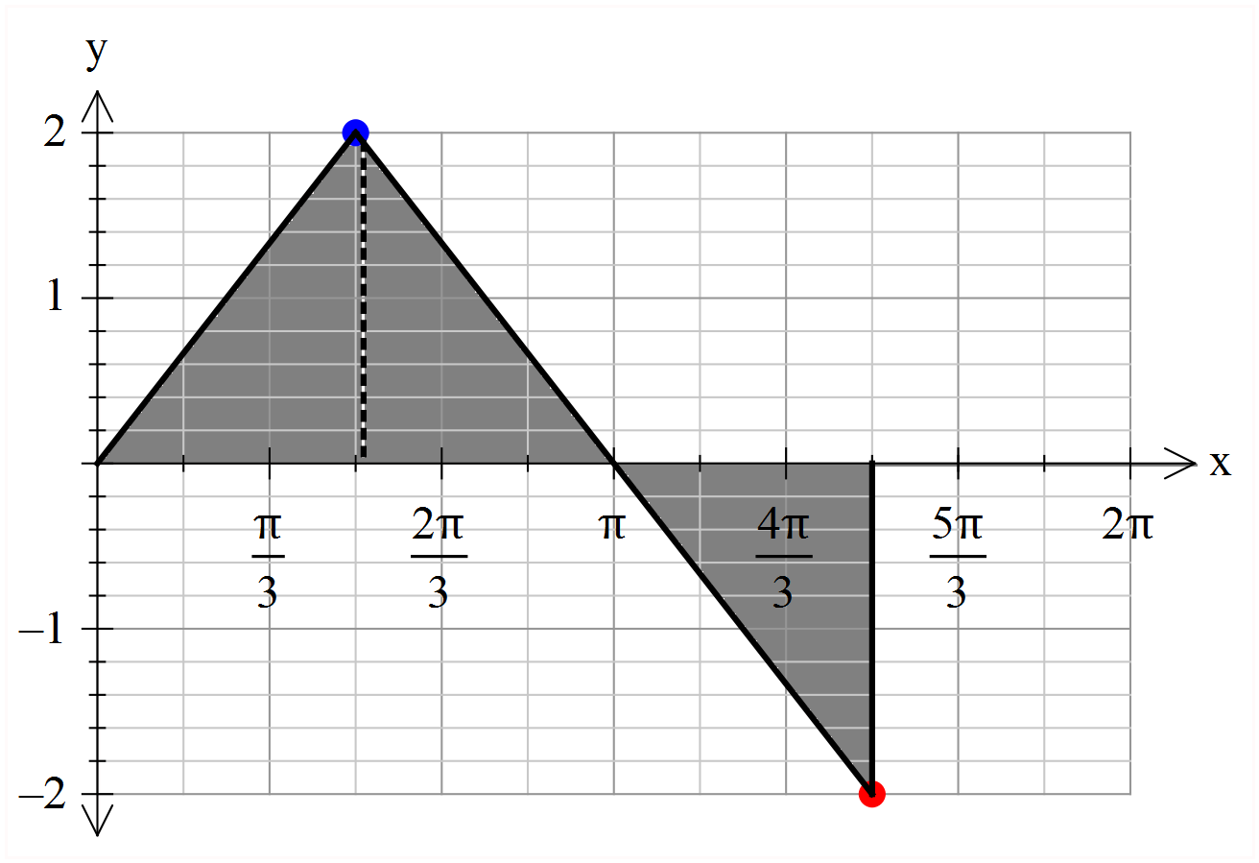

Marking key/mathematical behaviours | marks
- uses the sum of the areas to determine the distance travelled  - calculates the distance correctly  - explains how the particle travelled relative to the starting position | 1  1  1

Question 1 (e)
Solution
After seconds, both particles will be at the same position relative to the starting point. (both particles are initially at 0 and have the same velocity function)
After seconds, the first particle will be back at its starting point.
However, the second particle has a velocity function that is always positive, so it comes to instantaneous rest after seconds and then continues in the same direction for the second lot of seconds, ending up metres of the positive side of the starting point.
Hence the two particles are metres apart after seconds of travel.
Marking key/mathematical behaviours | marks
- indicates that the first particle is at the origin when  - notes how particle two moves differently to particle one for the second seconds of its travel.  - States the correct answer | 1  1  1

Question 1 (f)
Solution
For the first seconds, both particles move in the same manner, with the same velocity and acceleration. During the first seconds both particles move under the influence of the same constant acceleration (= m/sec²). Both slow down with the same negative acceleration for the next seconds (=-m/sec²) and are at are at metres to right of the origin at this time. Particle one then turns and goes back to the origin, mirroring the travel of the first seconds, but in reverse. Particle two, continues in the same direction repeating it motion of the first seconds
Marking key/mathematical behaviours | marks
- indicates that both particles move in the same way for the first half of the time.  - describes the motion in terms of velocity, acceleration and final position of the two particles during the first half of the journey.  - explains the difference in velocity and acceleration for the second half | 1  1  2

Question 2 (a)
Solution
Total cost = = Area under the graph of + the fixed costs
The Area
Marking key/mathematical behaviours | marks
- recognises to determine the area  - determines the area under for  - adds the fixed costs | 1  2  1

Question 2 (b)
Solution
For ,
Marking key/mathematical behaviours | marks
- determines  - recognises = over the given interval  - correctly determines | 1  1  1

Question 2 (c)
Solution
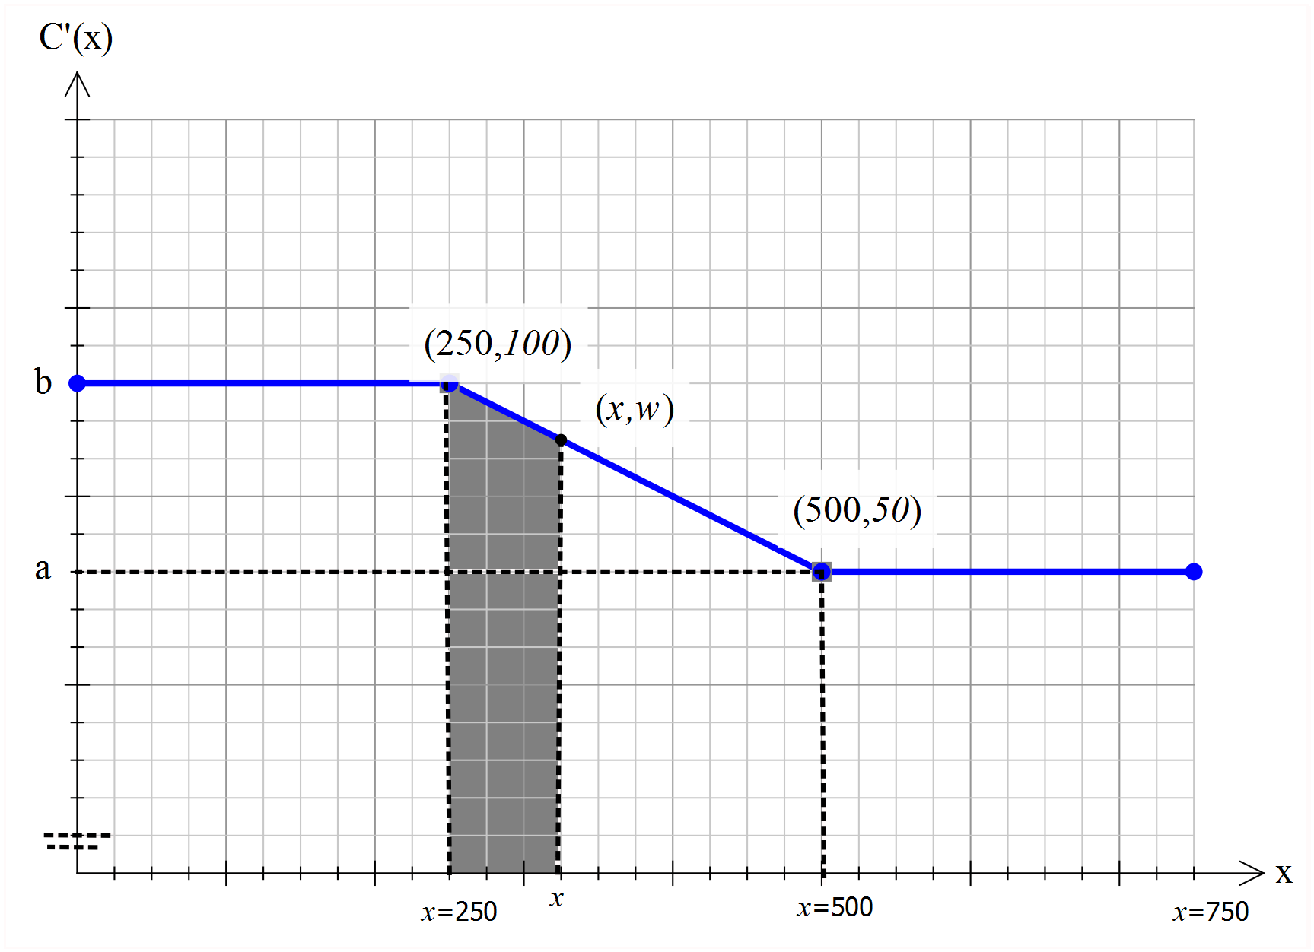
For , the cost function
= fixed costs + area shaded above, plus the area to the left of that shaded area above
= 5000+ + Area of shaded trapezium.
In order to calculate the shaded area, we need to find the length of the side of the trapezium at (which is).
Consider the gradient of the line forming for
Hence the shaded area = (sum of the parallel sides)
Marking key/mathematical behaviours | marks
- indicates how to determine (in words, on a diagram or both)  - substitues the values  - determines the equation of the line defining for  - determines the shaded area correctly  - determines correctly  - applies and simplifies to show the required result | 1  1  2  2  2  2

Question 2 (d)
Solution
Need to determine for and then write as piecewise defined function over the full domain.
For,
And for ,with
Hence,
Marking key/mathematical behaviours | marks
- determiness over the interval  - determines over the interval  - re-evaluates for the interval  - uses the result of part (b) and the calculations above to determine | 2  2  2  2

